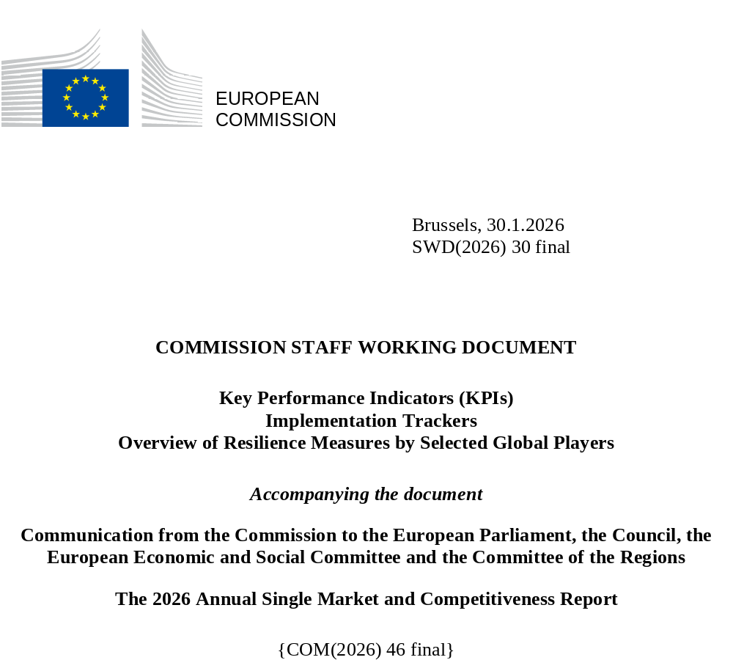

Table of contents

Annex 1 4
Key performance indicators (KPIs) 4
1. A functioning Single Market 6
KPI 1: Labour productivity 6
KPI 2: Integration in the Single Market 7
KPI 3: Simplification of EU rules 8
KPI 4: Conformity deficit 9
KPI 5: Ease of regulatory compliance 10
KPI 6: Recognition of professional qualifications 11
KPI 7: Length of standard-setting procedures 12
KPI 8: Circular material use rate 13
KPI 9: Product compliance monitoring 14
KPI 10: Services Regulation, Intra-EEA Services Trade Restrictiveness Index 15
KPI 11: Degree of digitalisation and cross-border accessibility 16
2. Closing the innovation gap 17
KPI 12: R&D expenditure 17
KPI 13: Patent applications 18
KPI 14: Digital technologies adoption by companies 19
KPI 15: Employment rate 20
KPI 16: Labour shortages relevant for the green transition 21
KPI 17: PISA scores 22
3. Decarbonisation of industry and investment 23
KPI 18: Private investment 23
KPI 19: Public investment 24
KPI 20: Venture capital investment 25
KPI 21: EU investments supporting the industrial transition 26
KPI 24: Electricity prices for businesses 27
KPI 23: Electrification rate 28
KPI 24: Energy from renewable sources 29
KPI 25: Annual growth in renewable electricity generation 30
4. Increasing security and reducing dependencies 31
KPI 26: Trade with the rest of the world 31
KPI 27: The EU economy’s global market share 32
KPI 28: Domestic clean tech manufacturing capacity 33
KPI 29: External vulnerability 34

Annex 2 35
Implementation trackers 35
1. A Competitiveness Compass for the EU (adopted on 29 January 2025) 35
2. The Clean Industrial Deal: A joint roadmap for competitiveness and decarbonisation (adopted on 26 February 2025) 38
3. The Single Market Strategy (adopted on 21 May 2025) 41
Annex 3 44
Overview of resilience measures by selected global players 44
1. Introduction 44
2. Overview of resilience measures by category and by countries 46
2.1 Industrial strategies, regulatory measures and crisis preparedness 46
United States 46
United Kingdom 47
Japan 48
Republic of Korea  48
Singapore 48
Australia  48
India 49
Canada 49
2.2 Financial and fiscal support (including R&D) 49
United States 49
Canada 50
United Kingdom 50
India 50
Taiwan 51
Japan 52
Republic of Korea 53
Brazil  53
2.3 Public procurement and prioritisation measures of domestic supply of goods and services 53
United States 53
Canada 54
India 54
China 54
United Kingdom 55
South Africa 55
2.4 Trade toolbox (tariffs, export restrictions, anti-coercion measures, FDI control, etc.) 55
United States 55
Canada 55
Australia 56
India 56
China 56
Japan 57
2.5 International deals and partnerships 57
BILATERAL PARTNERSHIPS 57
United States 57
United Kingdom 61
Australia 62
India 62
Japan 63
Republic of Korea 63
Vietnam 63
PLURILATERAL AND MULTILATERAL PARTNERSHIPS 63

Annex 1

Key performance indicators (KPIs)
Table 1: Summary of KPIs
Legend: | Improvement year-on-year | Stable | Worsening year-on-year | Single observation

KPI | What it measures | Latest EU values
A functioning Single Market
KPI 1: Labour productivity | GDP per hour worked in PPP terms. | At 78.5% of US levels (2024)  At 78.0% of US levels (2023)
KPI 2: Integration in the Single Market | Share of EU GDP represented by trade between EU Member States. | 22.0% for goods (2024)  23.5% for goods (2023)  7.9% for services (2024)  7.7% for services (2023)
KPI 3: Simplification of EU rules | Projected annual administrative savings from Commission’s omnibus simplification proposals and other initiatives. | EUR 15 bn (2025)
KPI 4: Conformity deficit | Share of transposed EU Single Market Directives for which infringement proceedings for incorrect transposition were launched. Target <= 0.5%. | 1.1% (2025)  0.9% (2024)
KPI 5: Ease of regulatory compliance | Replies to the survey question: ‘...how easy is it for companies to comply with government regulation and administrative requirements?’ | 3.89 out of 7 (2025)  3.66 out of 7 (2024)
KPI 6: Recognition of professional qualifications | Positive recognition rates as % (EU average) of all received requests for recognition of professional qualifications. | 82.2% (2023)  77.3% (2022)
KPI 7: Length of standard-setting procedures | Average length (in years) of the drafting stage of standards. | 4.0 (2024)  3.2 (2023)
KPI 8: Circular material use rate | Material recovered and fed back into the economy, as a share of the overall use of material. Target = 24% in 2030. | 12.2% (2024)  12.1% (2023)
KPI 9: Product compliance monitoring | Median number of product investigations per million inhabitants in EU Member States. | 102 (2024)  82 (2023)
KPI 10: Services trade restrictiveness | Restrictiveness of regulation in selected service sectors. | 4.2% (2024)  4.2% (2023)
KPI 11: Digitalisation of Single Market relevant procedures | Share of Single Market relevant administrative procedures that are fully online for national and cross-border users. | 20.6% (2024)
Closing the innovation gap
KPI 12: R&D expenditure | Total private and public expenditure in research and development as a share of GDP. Target = Above 3% by 2030. | 2.24% (2024)  2.26% (2023)
KPI 13: Patent applications | Patent applications per million inhabitants. | 152 (2024)  153 (2023)
KPI 14: Digital technologies adoption by companies | Share of European enterprises that have taken up cloud computing services, data analytics and/or Artificial Intelligence.  Target = 75% by 2030. | Artificial intelligence:  20% (2025), 13.5% (2024)  Data analytics:  39.9% (2025), 33.2% (2023)  Cloud computing services:  46.7% (2025), 38.9% (2023)
KPI 15: Employment rate | The share of working-age people employed. Target = 78% by 2030. | 75.8% (2024)  75.3% (2023)
KPI 16: Labour shortages relevant for the green transition | Number of occupations requiring specific skills for the green transition where at least five Member States reported a shortage. | 25 (2024)  13 (2023)
KPI 17: PISA score | 15-year-olds’ performance in the OECD’s PISA tests. High scores indicate better performance. | Maths:  474 (2022), 492 (2018)  Reading:  475 (2022), 488 (2018)  Science:  484 (2022), 488 (2018)
Decarbonisation of industry and investment
KPI 18: Private investment | Private investment (share of GDP). | 17.6% (2024)  18.6% (2023)
KPI 19: Public investment | Public investment (share of GDP). | 3.7% (2024)  3.6% (2023)
KPI 20: Venture capital investment | Venture capital investment (share of GDP). | 0.06% (2024)  0.06% (2023)
KPI 21: EU investments supporting industrial transition | Cumulative volume of InvestEU investments supporting industrial transition. | EUR 115.5bn (Jun 2025)  EUR 52.7 bn (Jun 2024)
KPI 22: Electricity prices for non-household consumers | Electricity prices for non-household consumers (EU ID price band, large commercial users). | EUR 0.164 per kWh (2025)  EUR 0.163 per kWh (2024)
KPI 23: Electrification | Electricity as a share of the total (final) energy consumption. Objective = 32% in 2030. | 22.9% (2023)  22.9% of (2022)
KPI 24: Share of energy from renewable sources | Renewable energy generation as a share of the overall energy consumption.  Target = 42.5% in 2030. | 25.2% (2024)  24.5% (2023)
KPI 25: Annual growth in renewable electricity generation | The annually added capacity to generate renewable electricity. Objective = + 100 GW. | +68 GW (2024)  +67 GW (2023)
Increasing security and reducing dependencies
KPI 26: Trade with the rest of the world as share of GDP | The EU’s degree of economic integration with the rest of the world. | 13.9 % for goods (2024)  14.7% for goods (2023)  8.1% for services (2024)  7.8% for services (2023)
KPI 27: Exports of goods and services as a share of worldwide imports | The EU economy’s market share. | 12.6% for goods (2024)  11.9% for goods (2023)  25.0% for services (2024)  25.4% for services (2023)
KPI 28: Domestic clean tech manufacturing capacity | The share of clean tech components tracked under the Net-Zero Industry Act that meet the benchmark domestic manufacturing rate.  Target = 100% of the tracked components. | 6 out of 27 (22%) technology components exceed the benchmark manufacturing rate (2024)
KPI 29: External vulnerability | External vulnerabilities for strategically important industrial products. | 0.20 (2023)  - (2022)
This annex zooms in on each of the Report’s 29 KPIs, showing the evolution of EU performance over time and data by individual Member State as available. It includes the latest available data for each KPI, with data sources last accessed on 15 January 2026.

A functioning Single Market

KPI 1: Labour productivity
KPI 1 shows the trend in labour productivity, meaning the economic output per hour worked in the economy (in PPS terms). EU indexed at 100 for 2024.
The EU shows a persistent productivity gap in relation to the US, with labour productivity significantly below US levels for the past 30 years, currently 21% lower.

Figure 1: Labour productivity in the EU and other advanced economies.
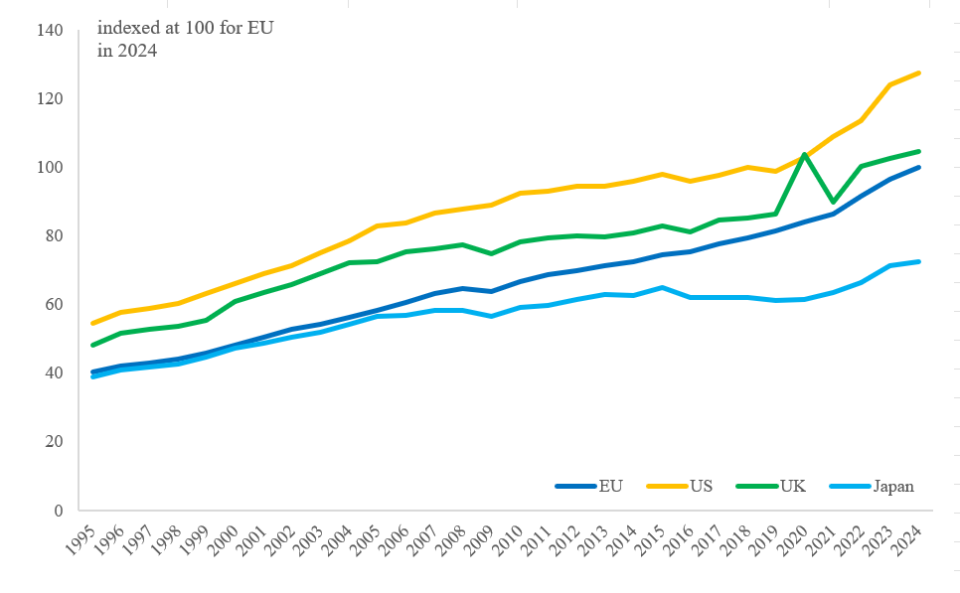
Source: European Commission services calculations based on AMECO database, series: UVGD PPS and NLHT

KPI 2: Integration in the Single Market
KPI 2 shows the trend in cross-border trade flows in goods and services within the EU Single Market as a share of total EU GDP. Trade is measured by the average of imports and exports.
Since the creation of the Single Market in 1993, trade in goods and services as share of GDP has steadily risen. After a strong increase in 2022, trade in goods has fallen back to pre-2022 levels. Disaggregated trade data suggest that these changes can, to a great extent, be attributed to trade fluctuations in energy products, linked to the significant price volatility in the wake of the Russian war of aggression against Ukraine. Trade in services continues to expand, albeit at a slow pace, after its pandemic-related dip.
Figure 2: Integration in the Single Market: Intra-EU trade in goods and services.
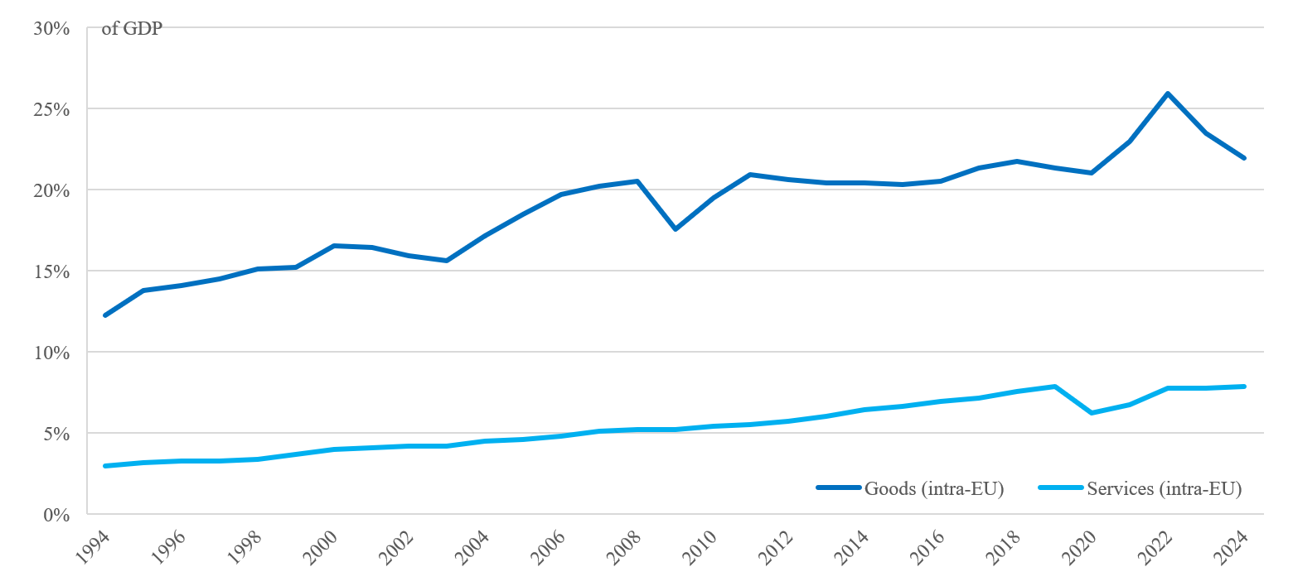
Source: Eurostat
The indicator only covers intra-EU trade. If considering trade with non-EU EEA partners (Norway, Iceland and Liechtenstein), values for Member States with significant trade ties to non-EU EEA countries would be higher.
National data, intra-EU goods, % of GDP (2024)
AT | BE | BG | CY | CZ | DE | DK | EE | EL | ES | FI | FR | HR | HU
29.7 | 51.2 | 27.0 | 12.7 | 53.9 | 19.7 | 18.1 | 37.8 | 15.0 | 15.3 | 17.2 | 13.0 | 28.8 | 51.1
IE | IT | LT | LU | LV | MT | NL | PL | PT | RO | SE | SI | SK | EU
12.8 | 14.7 | 33.8 | 19.3 | 38.9 | 16.1 | 40.3 | 29.3 | 23.8 | 22.3 | 19.3 | 54.0 | 63.9 | 22.0

National data, intra-EU services (excluding financial services and transport for national data), % of GDP (2024)
AT | BE | BG | CY | CZ | DE | DK | EE | EL | ES | FI | FR | HR | HU
9.3 | 10.8 | 4.8 | 16.2 | 5.6 | 4.0 | 7.5 | 13.9 | 4.8 | 4.5 | 6.8 | 4.4 | 10.9 | 7.0
IE | IT | LT | LU | LV | MT | NL | PL | PT | RO | SE | SI | SK | EU
17.4 | 2.9 | 7.5 | 38.4 | 7.4 | 36.8 | 9.1 | 4.8 | 6.7 | 5.2 | 7.9 | 8.5 | 4.8 | 7.9

KPI 3: Simplification of EU rules
KPI 3 measures the projected annually recurring administrative savings expected from the Omnibus simplification proposals and other initiatives, at the time of their adoption by the Commission. It shows the accumulated expected savings of these proposals put forward up until the end of December 2025.
In 2025, the Commission has proposed ten Omnibus proposals.and other initiatives which are projected to reduce the recurrent administrative annual costs by EUR 15 bn, of which EUR 11.9 bn from omnibus proposals and EUR 3.1 bn from other initiatives. Moreover, new initiatives, such as European Business Wallet Regulation has a potential to contribute significantly to the overall administrative cost reduction for businesses and public administrations, with minimum EUR 13.5 bn. These savings were estimated using the EU standard cost model.
Administrative burdens have been estimated at EUR 150 bn per year. The Commission targets to reduce these by at least 25% (amounting to EUR 37.5 bn) for all businesses and by at least 35% for SMEs.
This KPI tracks progress related to the objective of addressing overly complex EU rules – one of the “Terrible Ten” barriers identified in the Single Market Strategy.

Figure 3: Savings expected from Commission’s Omnibus simplification packages and other initiatives: towards a 25% reduction in recurrent administrative burden.
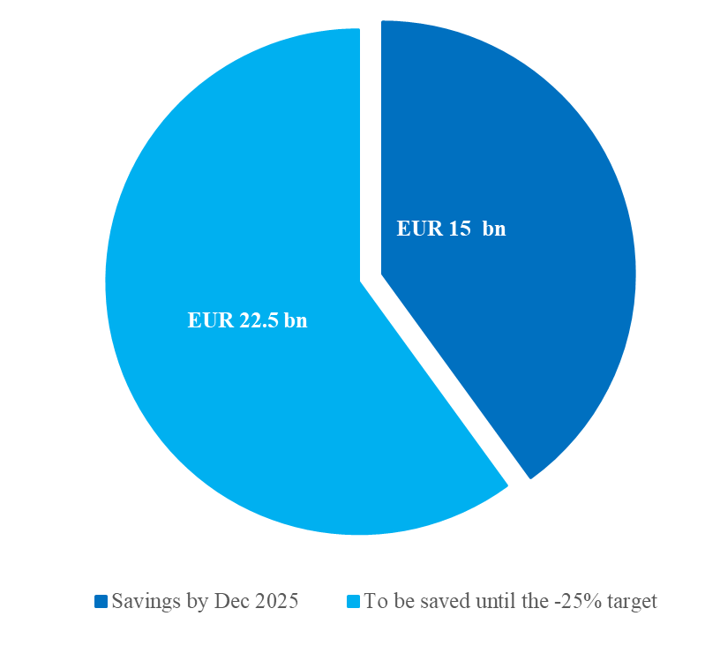
Source: European Commission services, Simplification - European Commission

KPI 4: Conformity deficit
KPI 4 measures the share of transposed Single Market directives for which the Commission has launched infringement proceedings due to incorrect transposition. It is expressed as percentage of the number of Single Market directives notified to the Commission as ‘transposed’ or ‘not requiring any further implementation measures’.
This KPI tracks progress related to the objective of addressing the lack of Single Market ownership by Member States – one of the “Terrible Ten” barriers identified in the Single Market Strategy.
The conformity deficit increased to 1.1% in 2025, remaining much above the target of 0.5%, with wide variation among Member States.
Figure 4a: Conformity deficit: share of incorrectly transposed Single Market Directives.
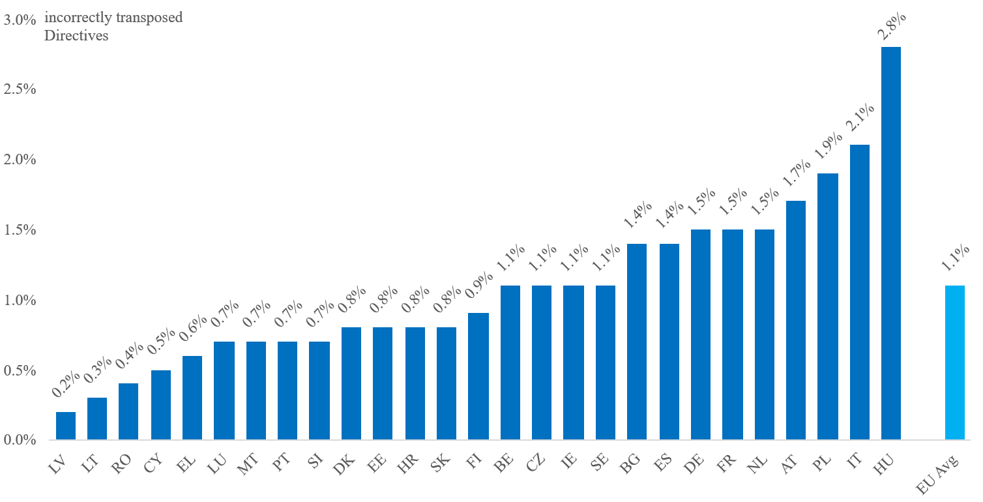
Figure 4b: Evolution of the EU average conformity deficit.
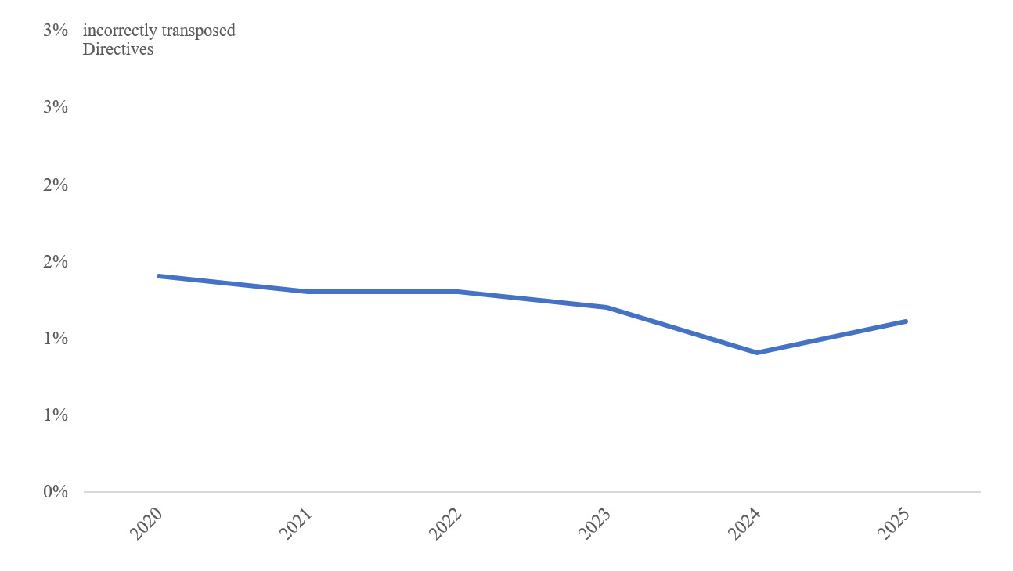
Source: European Commission services

KPI 5: Ease of regulatory compliance
KPI 5 measures companies’ perceived ease of regulatory compliance by tracking the results of replies to the following survey question: ‘In your country, how easy is it for companies to comply with government regulatory and administrative requirements (e.g. permits, reporting, legislation) (1 = Overly complex; 7 = Extremely easy)?’ Higher values indicate a better performance, i.e. less burdensome regulation.
This KPI tracks progress related to the objective of easing business operations, since complicated business establishment and operations due to regulation is one of the “Terrible Ten” barriers identified in the Single Market Strategy.
According to the World Economic Forum the ease of regulatory compliance in the EU has been broadly stable over the past years.
Figure 5: Ease of regulatory compliance: Companies’ perception of the ease of doing business.
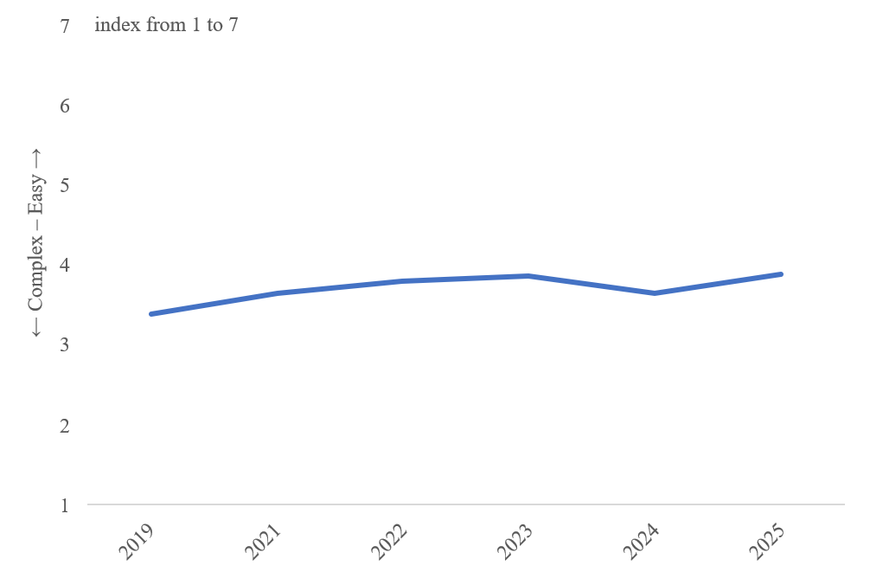

Source: World Economic Forum, Executive Opinion Survey (2025)
National data (2025)
AT | BE | BG | CY | CZ | DE | DK | EE | EL | ES | FI | FR | HR | HU
3.05 | 4.51 | 4.04 | 4.33 | 3.02 | 3.99 | 3.89 | 3.99 | 3.19 | 2.74 | 5.15 | 4.18 | 2.82 | 2.99
IE | IT | LT | LU | LV | MT | NL | PL | PT | RO | SE | SI | SK | EU
4.59 | 3.69 | 5.05 | 4.85 | 3.0 | 4.07 | 3.94 | 3.18 | 3.21 | 3.16 | 4.98 | 2.57 | 2.67 | 3.89

KPI 6: Recognition of professional qualifications
KPI 6 measures response rates (positive, pending and negative) of all the requests received for recognition of professional qualifications. Such requests are made when a person having a professional qualification certified in their home Member State seeks to get their qualifications recognised in another Member State in order to work there.
This KPI tracks progress related to the objective of simplifying recognition of professional qualifications – one of the “Terrible Ten” barriers identified in the Single Market Strategy.
Of the initiated recognition procedures, in 2023, 10% are pending a decision, while 8% have resulted in a negative decision, with considerable differences across Member States.
Figure 6a: Recognition of professional qualifications per Member State.
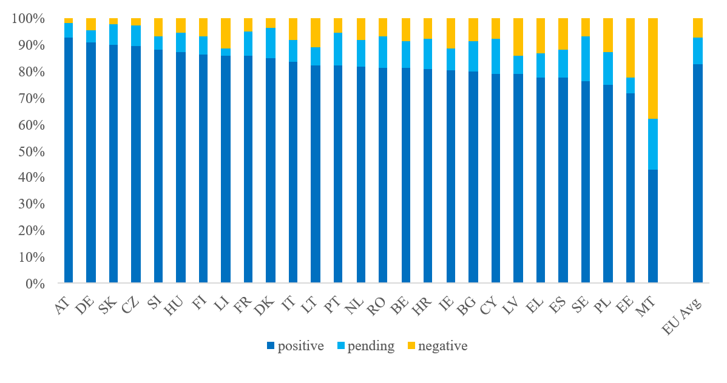
Figure 6b: Evolution of the EU average of recognition decisions.
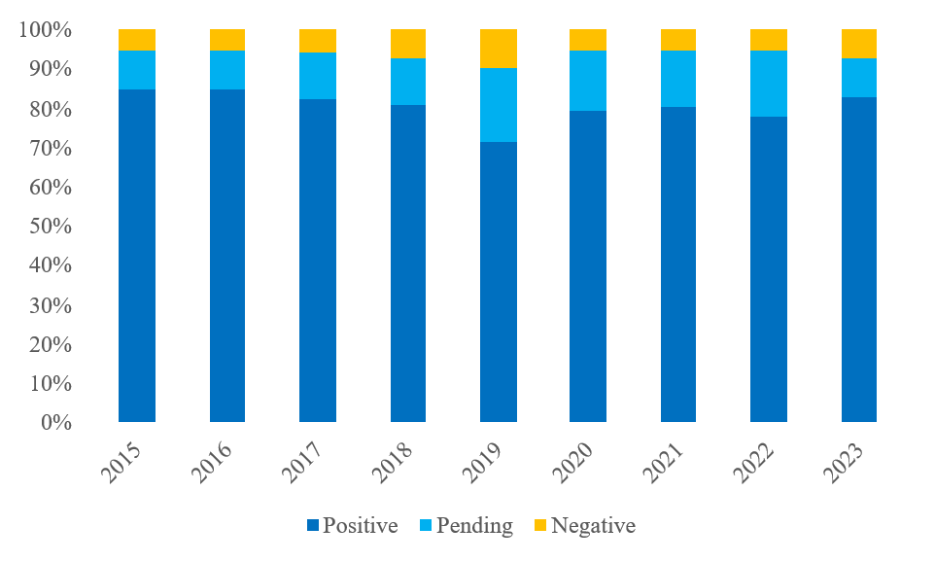
Source: European Commission services calculatoins based on the Regulated professions database

KPI 7: Length of standard-setting procedures
KPI 7 measures the average length in years of the drafting stage of standards.
This KPI tracks progress related to the objective of speeding up standard-setting procedures – one of the “Terrible Ten” barriers identified in the Single Market Strategy.
The European standardisation system is hindered by the slow pace of the standard development process, which fails to meet market and legislative needs, particularly for new technologies. Over the past decade, the average time needed to establish a new standard has gradually increased, which weighs on the competitiveness of EU industry. Several factors contribute to this slow pace, including outdated working methods and the underuse of digital technologies.

Figure 7: Average length of the drafting stage in standard-setting procedures.
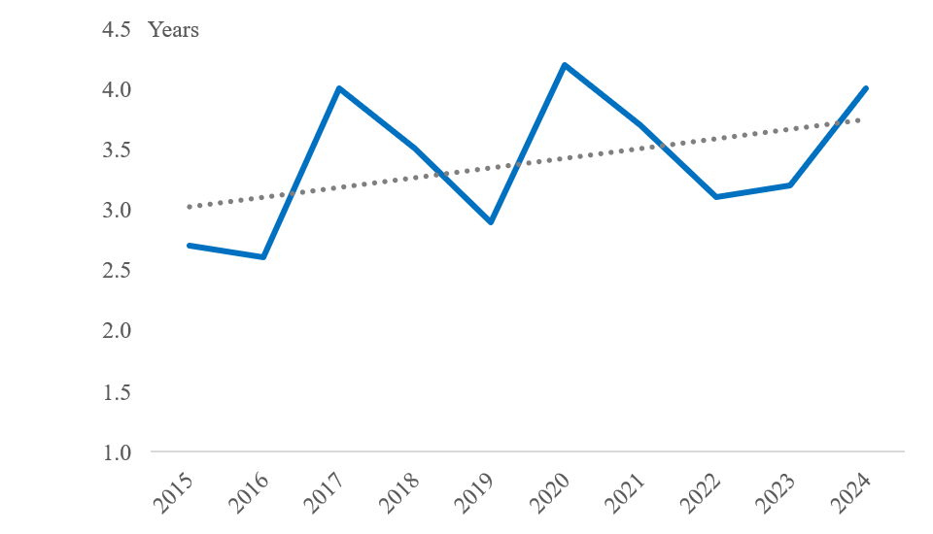
Source: European Commission services, Evaluation study of the regulation (EU) 1025/2012 on European standardisation - Publications Office of the EU

KPI 8: Circular material use rate
KPI 8 measures the degree of the economy’s circularity by looking at the rate of use of secondary materials as share of the overall demand for materials. When secondary raw materials replace primary materials in the economy, they reduce pressure on primary resources and limit waste. A higher rate indicates a higher degree of circularity.
This KPI tracks progress related to the objective of harmonising today’s fragmented rules on packaging, labelling and waste – one of the “Terrible Ten” barriers identified in the Single Market Strategy.
The share of material brought back into the economy out of the overall use of materials goes up slowly, from 12.1% in 2023 to 12.2% in 2024, but is still well below the target of 24% in 2030.
Figure 8a: Circular material use rate by Member State.
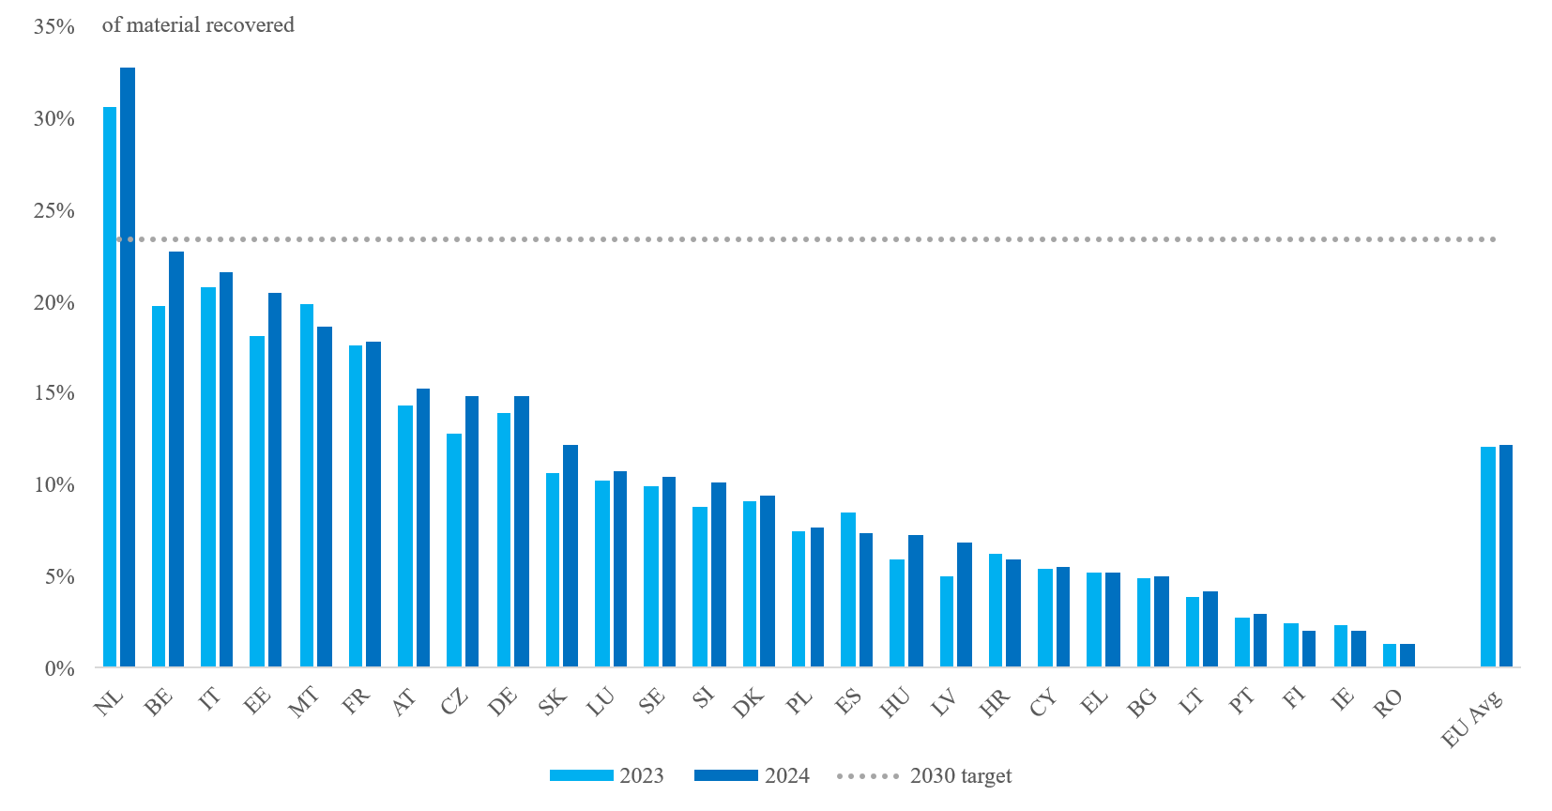
Figure 8b: Evolution of the EU average circular material use rate.
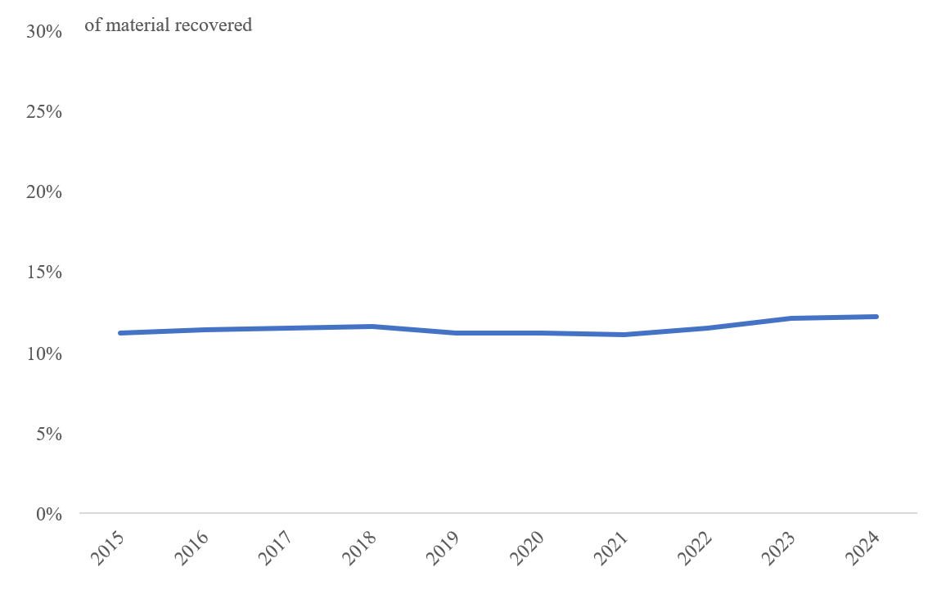
Source: Eurostat

KPI 9: Product compliance monitoring
KPI 9 measures the number of product investigations carried out by market surveillance authorities per million inhabitants in EU Member States.
This KPI tracks progress related to the objective of modernising product rules and addressing the lack of product compliance – one of the “Terrible Ten” barriers identified in the Single Market Strategy.
EU market surveillance is characterised by low, if increasing, number of investigations notified by national authorities.
Figure 9a: Product compliance investigations conducted per million inhabitants.
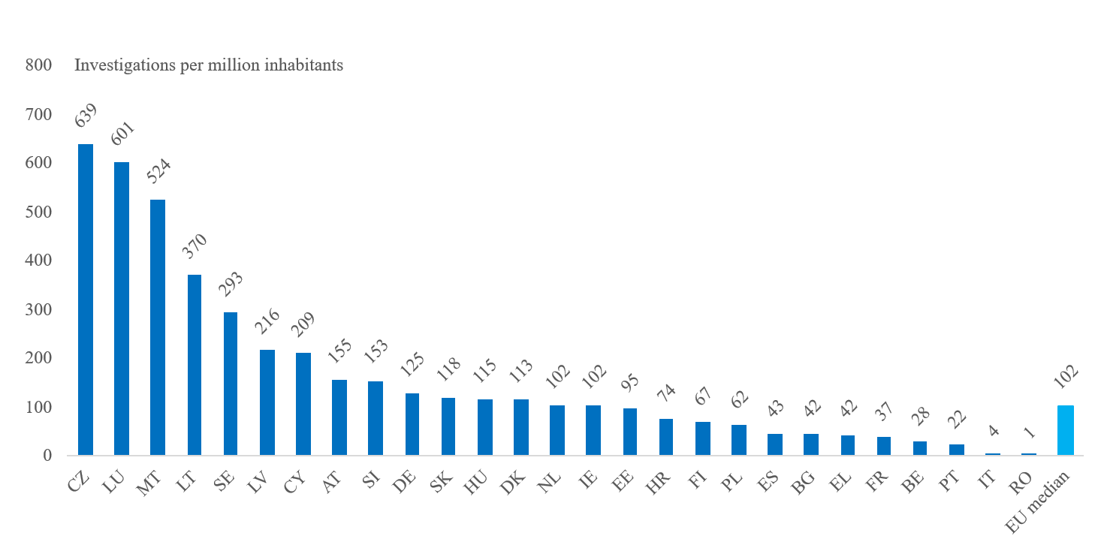
Figure 9b: Evolution of EU product compliance investigations.
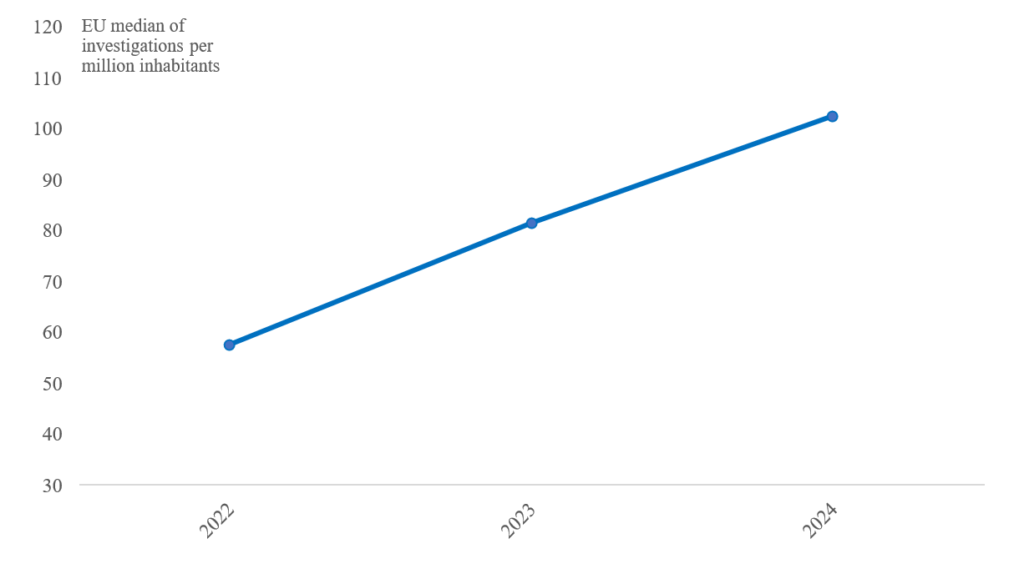
Source: European Commission services

KPI 10: Services Regulation, Intra-EEA Services Trade Restrictiveness Index
KPI 10 measures the level of restrictiveness of regulation in selected services sectors (construction services, courier services, architecture services, engineering services, legal services). The values are based on the OECD’s intra-EEA STRI questionnaire and show the share of catalogued restrictions to trade in services that are present in selected sectors. They are available for 22 of the 27 EU Member States.
This KPI tracks progress related to the objective of addressing restrictive and diverging national regulations on services – another of the “Terrible Ten” barriers identified in the Single Market Strategy.
Based on the indicator, the level of restrictiveness has remained stable in recent years, despite efforts to remove restrictions.
Figure 10a: Services Regulation, Intra-EEA Services Trade Restrictiveness Index for selected sectors by EU Member State.
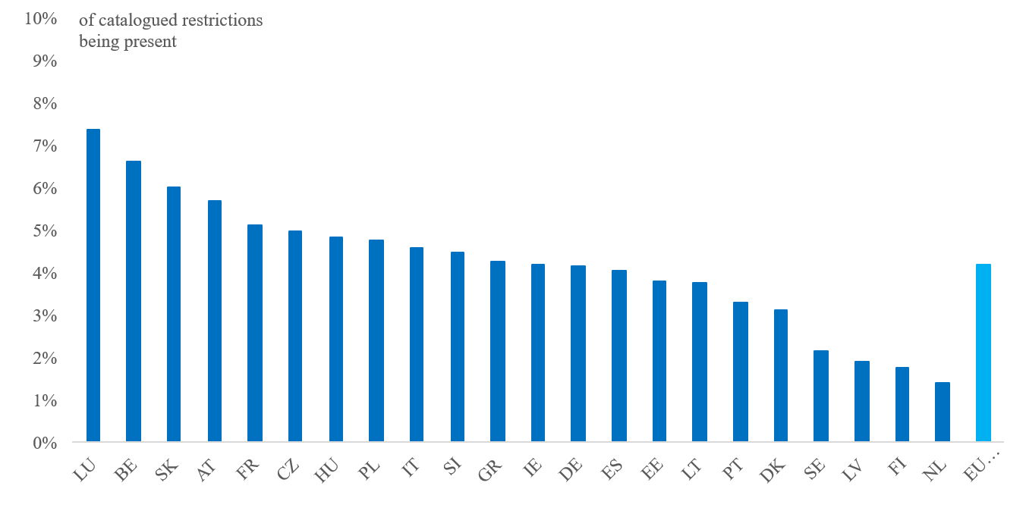
Figure 10b: Evolution of the EU average in the Intra-EEA Services Trade Restrictiveness Index.
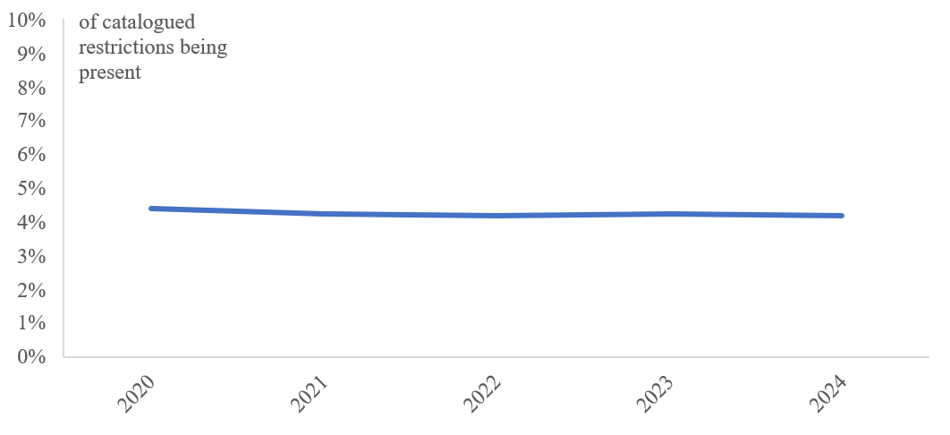
Source: OECD

KPI 11: Degree of digitalisation and cross-border accessibility
KPI 11 measures the share of Single Market relevant administrative procedures required under the Single Digital Gateway Regulation to be online, that are fully online for both national and cross-border users. This includes aspects such as authentication and payment.
This KPI tracks progress related to the objective of digitalising the Single Market, as proposed by the Single Market Strategy.
The Single Digital Gateway (SDG) Regulation sets out the main e-government entry point, Your Europe, which citizens and businesses can use to access reliable and multilingual information on rights, obligations, and administrative procedures in all EU countries. It also provides links to national portals and online services to complete key procedures digitally. Progress on SDG implementationvaries across Member States. On average, in 2024, only 21% of procedures required to be online, were fully online for both national and cross-border users as per the specific requirements set out in Articles 6, 13 and 14 of the SDG Regulation. Based on the previous methodology that only measures the compliance with the requirement contained in Article 13.2(b) of the SDG Regulation, i.e. that the cross-border users are able to submit the required information, 54% of relevant procedures complied with this requirement.

Figure 11: Degree of digitalisation and cross-border accessibility of administrative procedures.
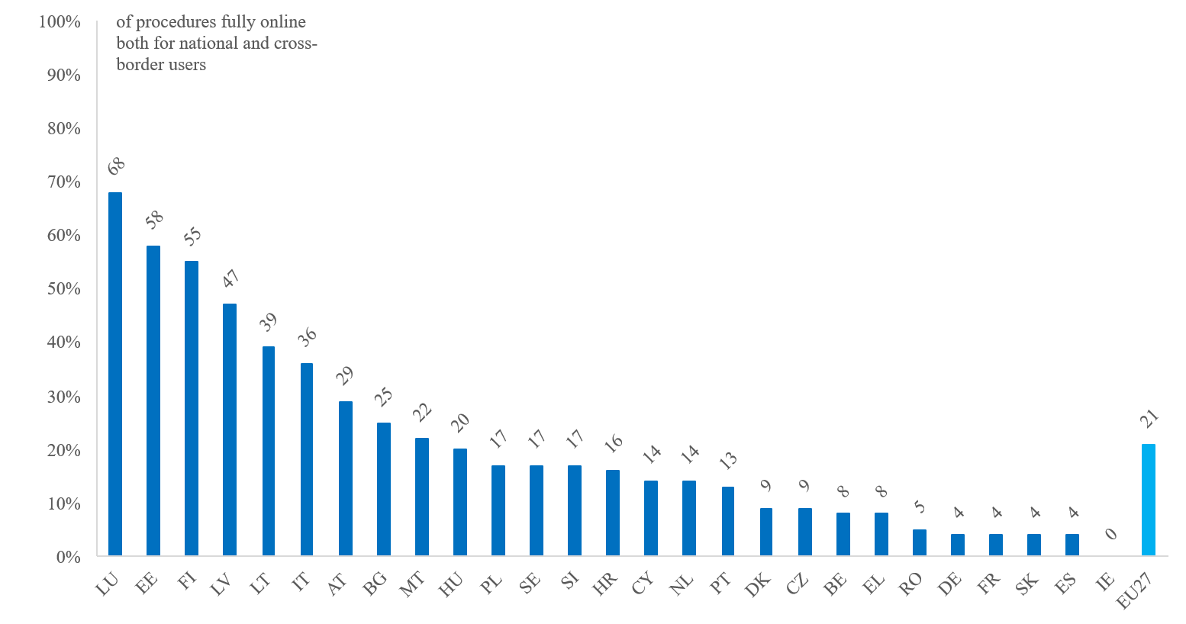Source: European Commission services

Closing the innovation gap

KPI 12: R&D expenditure
KPI 12 tracks trends in the combined annual private and public- sector expenditure in research and development (R&D) as a share of GDP for the EU, US, UK, Japan and China.
The EU’s total private and public-sector R&D expenditure reached 2.24% of GDP in 2024, still below the 3% target. Progress over the past 10 years remains modest. Comparing R&D expenditure with other major economies, the EU continues to trail behind the US, China, and Japan.

Figure 12: Research and development expenditure in the EU and other advanced economies.
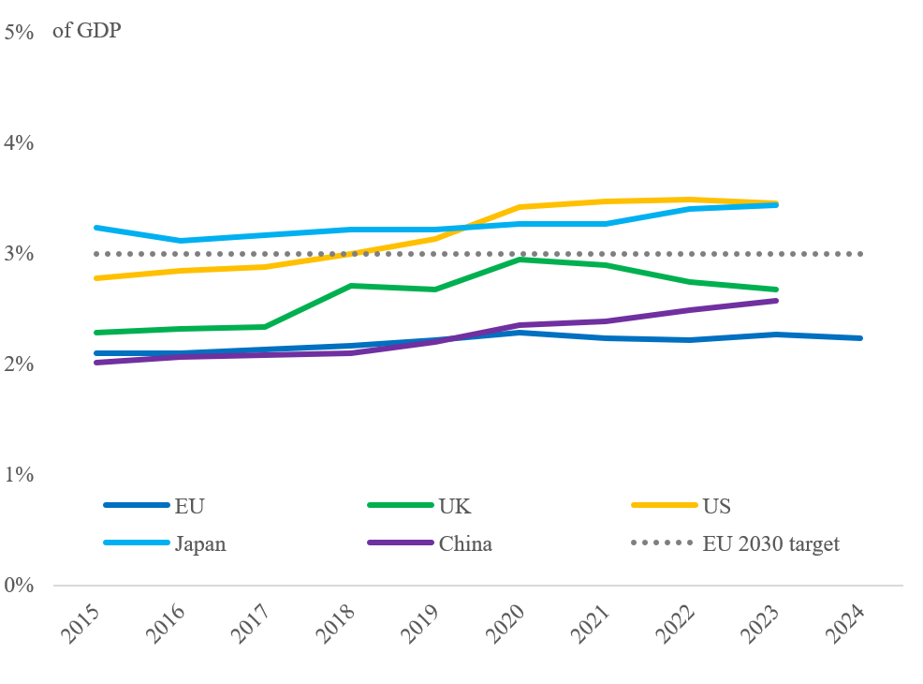
Source: Eurostat; World Bank
National data (2024)
AT | BE | BG | CY | CZ | DE | DK | EE | EL | ES | FI | FR | HR | HU
3.26 | 3.36 | 0.77 | 0.65 | 1.82 | 3.13 | 3.01 | 1.99 | 1.54 | 1.5 | 3.22 | 2.18 | 1.35 | 1.31
IE | IT | LT | LU | LV | MT | NL | PL | PT | RO | SE | SI | SK | EU
1.38 | 1.38 | 1.04 | 0.99 | 0.92 | 0.51 | 2.29 | 1.41 | 1.72 | 0.46 | 3.57 | 2.16 | 0.98 | 2.24

KPI 13: Patent applications
KPI 13 tracks the number of patent applications per million inhabitants in the EU, US, UK, Japan and China. Figure 14 shows i) the number of patent applications to the European Patent Office (EPO) by EU applicants per million inhabitants; and ii) the number of patents filed under the Patent Cooperation Treaty (PCT) per million inhabitants by applicants’ country of residence.
The number of EPO and PCT patent applications should not be directly compared because each system provides a different geographical scope of protection. Nonetheless, they are telling indicators of the degree of innovation in different countries.
The number of PCT patent applications filed by EU applicants fell from 104 per million inhabitants in 2022 to 98 in 2023. Similar, patent applications fell in the UK, with even steeper drops seen in the United States, Japan and China. In 2023, EU applicants still filed fewer PCT patents per capita than Japan (358 per million) and the United States (156), but more than China (40) and the UK (80).

Figure 13: Patent applications in the EU and other advanced economies.
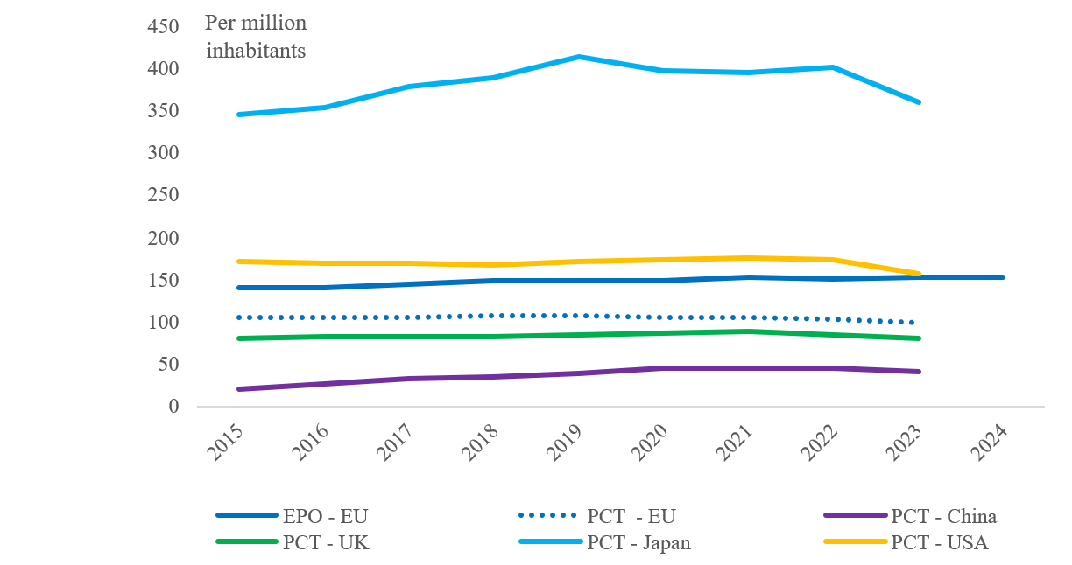
Source: Eurostat; OECD; World Bank
National data (2024), patent applications to the EPO per million inhabitants
AT | BE | BG | CY | CZ | DE | DK | EE | EL | ES | FI | FR | HR | HU
234 | 221 | 8 | 64 | 23 | 299 | 425 | 53 | 10 | 45 | 428 | 160 | 10 | 15
IE | IT | LT | LU | LV | MT | NL | PL | PT | RO | SE | SI | SK | EU
209 | 82 | 25 | 457 | 19 | 110 | 393 | 19 | 33 | 3 | 468 | 73 | 11 | 152

KPI 14: Digital technologies adoption by companies
KPI 14 measures the degree to which companies are adopting three key digital technologies: artificial intelligence (AI), data analytics, and cloud.
The AI series tracks the percentage of businesses employing 10 or more people using at least one AI technology. The data analytics series shows the percentage of businesses using data analytics tools. The cloud series tracks the percentage of businesses purchasing at least one intermediate or sophisticated cloud computing service. The indicator is calculated for all businesses in manufacturing and service sectors, excluding the financial sector.
By 2025, the rate of adoption of AI, cloud and/or dataanalytics by businesses in the EU had improved, but it remains well below the 75% target for 2030.
Figure 14a: Digital technologies adoption by companies in the Member States.
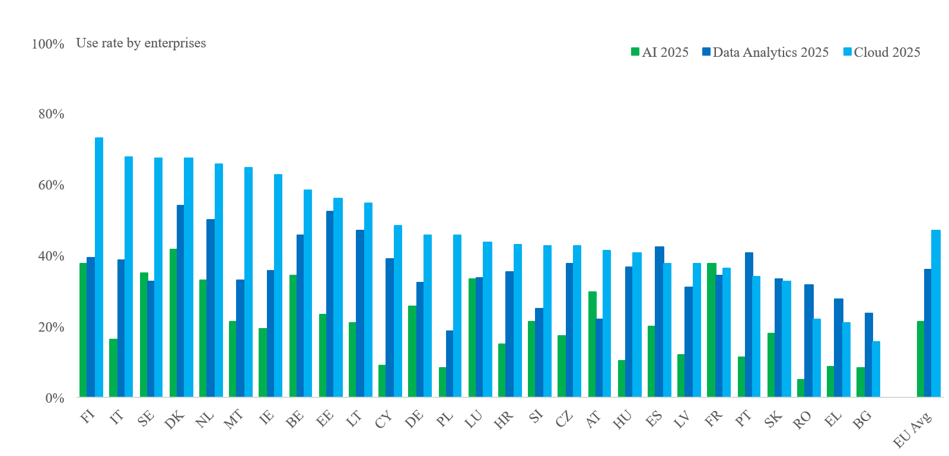
Figure 14b: Evolution of the EU average digital technologies adoption by companies.
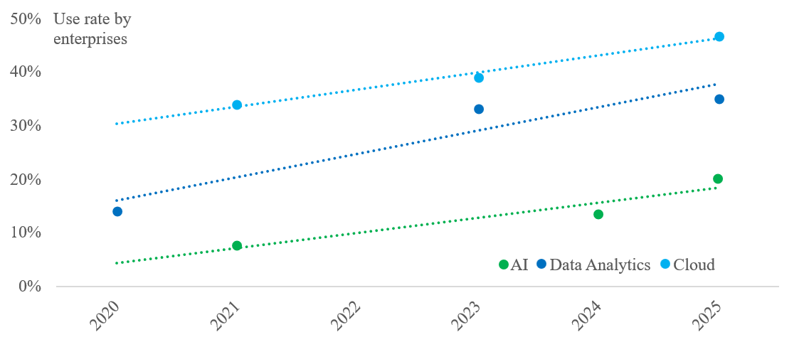
Source: European Commission services, Digital Economy and Society Index

KPI 15: Employment rate
KPI 15 shows the trends in employment rates of people of working- age between 20 to 64 in the EU, US, UK and Japan.
Employment rates in the EU are steadily increasing and on track to meet the EU’s headline target of 78% in 2030. The EU employment rate reached a record high of 75.8% in 2024, driven partly by increasing participation of older people, women and migrants in the work force. This performance is mostly in line with the US, but below the trends seen in Japan and the UK.

Figure 15: Employment rate in the EU and other advanced economies.
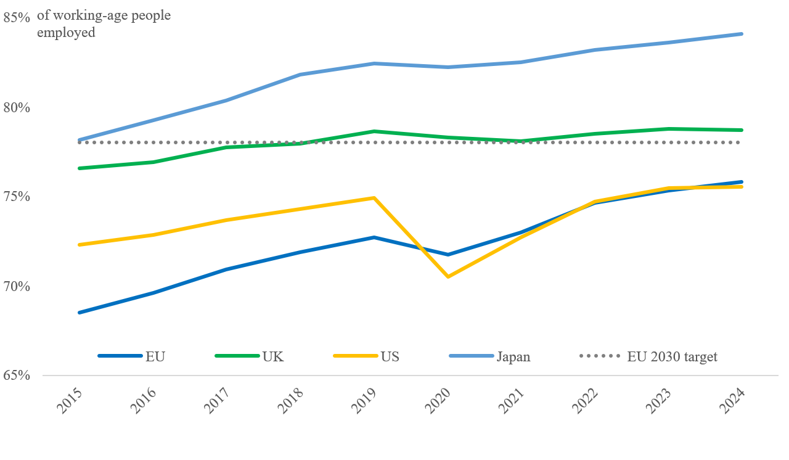
Sources: EU: Eurostat; EU Labour Force Survey (2024); Japan, UK, USA: Labour Force Survey
National data (2024)
AT | BE | BG | CY | CZ | DE | DK | EE | EL | ES | FI | FR | HR | HU
77.4 | 72.3 | 76.8 | 79.8 | 82.3 | 81.3 | 80.2 | 81.8 | 69.3 | 71.4 | 77.0 | 75.1 | 73.6 | 81.1
IE | IT | LT | LU | LV | MT | NL | PL | PT | RO | SE | SI | SK | EU
79.8 | 67.1 | 79.2 | 74.2 | 77.4 | 83.0 | 83.5 | 78.4 | 78.5 | 69.5 | 81.9 | 78.3 | 78.1 | 75.8

KPI 16: Labour shortages relevant for the green transition
KPI 16 shows the number of occupations requiring specific skills or knowledge for the green transition where at least five Member States reported a shortage. Occupations are considered relevant for the green transition if they require at least three green skills..
This KPI tracks progress against the objective laid down in the Clean Industrial Deal of reducing the number of occupations relevant for the green transition with labour shortage.
The green transition is expected to create between 1 and 2.5 million additional jobs by 2030 in the EU. However, many of these new jobs will be in sectors that already face labour shortages. The number of occupations with labour shortages has doubled in just one year. Such occupations include plumbers and pipe fitters (shortages in 20 Member States), insulation workers, civil engineers and air conditioning and refrigeration mechanics (14), civil engineering technicians (12) and roofers (11). They require technical and manual expertise essential to the green transition.

Figure 16: Labour shortages relevant for the green transition.
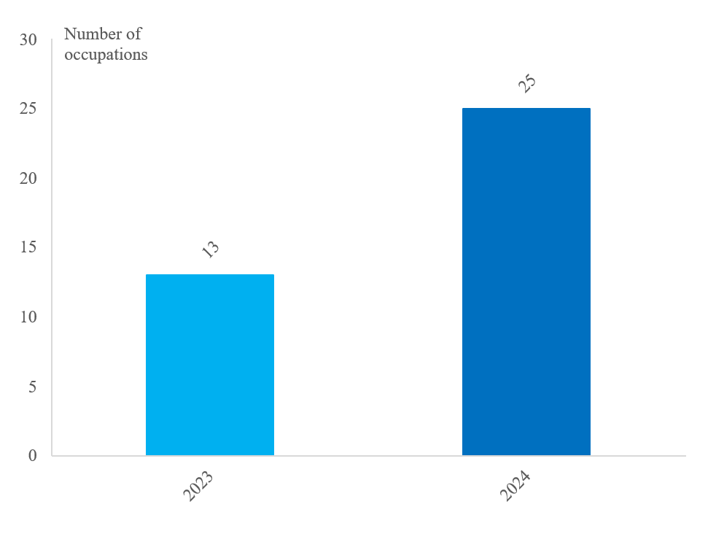
Source: European Commission services

KPI 17: PISA scores
KPI 17 tracks 15-year-olds’ performance in the OECD’s PISA tests covering maths, reading and science. Figure 18 shows the PISA scores for 2022, 2018 and 2015 for the EU, US, UK, Japan and China. The data for the EU are the average scores for the 27 Member States, weighted by the number of 15-year-olds enrolled in education.
The EU’s average PISA scores have fallen in all disciplines and EU students underperform compared to their peers in the UK, the US, Japan and China.

Figure 17: PISA scores for the EU and other advanced economies.
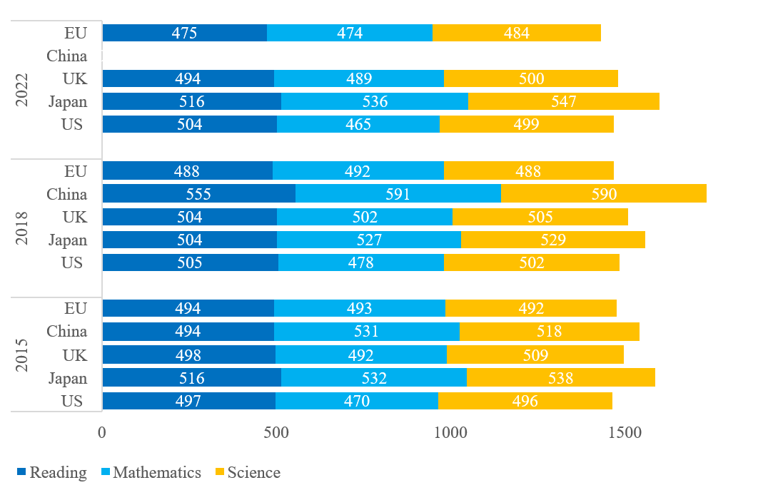
Source: OECD PISA database

Decarbonisation of industry and investment

KPI 18: Private investment
KPI 18 tracks the trends in private-sector investment (gross fixed capital formation) as a share of annual GDP for the EU, US and UK. The data refer to the increase in the capital stock owned by companies and individuals, including equipment, land, houses and other buildings, and intangible assetts such as R&D.
Private-sector investment fell by 3.2% in 2024. As a result, private investment as a share of GDP also fell to 17.6% of GDP in 2024 and is now on par with US levels, after being broadly stable and higher than in the US in recent years.

Figure 18: Private-sector investment in the EU and other advanced economies.
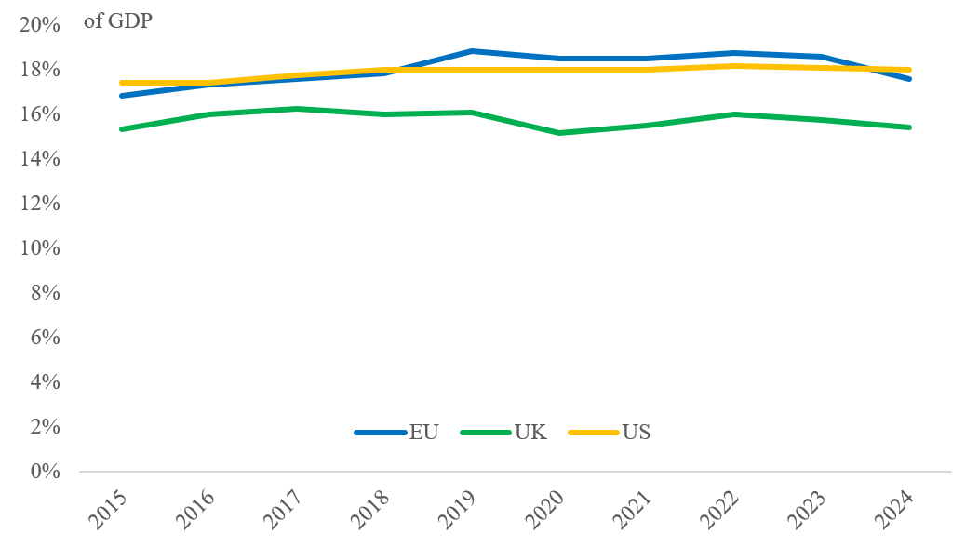
Source: AMECO database
National data, % of GDP (2024)
AT | BE | BG | CY | CZ | DE | DK | EE | EL | ES | FI | FR | HR | HU
19.6 | 21.1 | 15.2 | 17.8 | 21.8 | 17.4 | 20.2 | 17.7 | 12.4 | 17.6 | 17.6 | 17.8 | 20.0 | 18.8
IE | IT | LT | LU | LV | MT | NL | PL | PT | RO | SE | SI | SK | EU
14.8 | 18.6 | 18.2 | 10.7 | 16.1 | 15.3 | 16.6 | 12.2 | 17.7 | 19.4 | 19.6 | 15.8 | 16.9 | 17.6

KPI 19: Public investment
KPI 19 tracks the trends in public-sector investment (gross fixed capital formation) as a share of annual GDP in the EU, US and UK. Public-sector investment is a measure of how much money a country spends to increase the value of fixed assets (for example, road infrastructure, buildings and equipment).
Public-sector investment in 2024 edged up to 3.7% of GDP confirming the positive trend over the last years. This share and the trend are broadly similar to those seen in the US (3.4% of GDP), and higher than in the UK (3.2%).

Figure 19: Public-sector investment in the EU and other advanced economies.
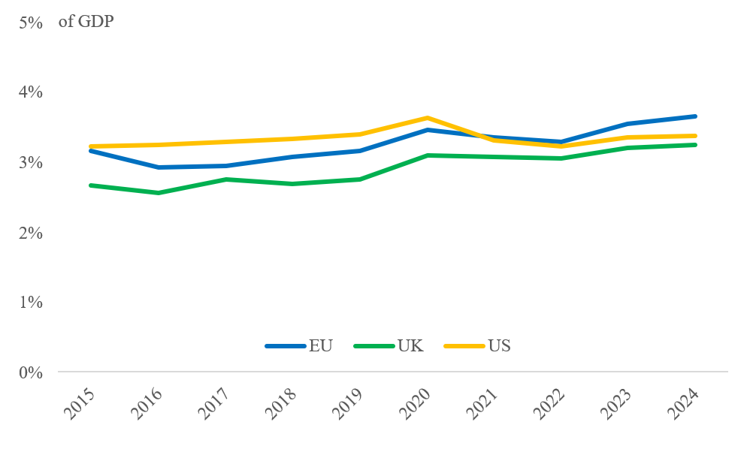
Source: AMECO database
National data, % of GDP (2024)
AT | BE | BG | CY | CZ | DE | DK | EE | EL | ES | FI | FR | HR | HU
3.9 | 3.1 | 3.2 | 2.8 | 4.7 | 3.1 | 3.2 | 6.2 | 3.6 | 2.7 | 4.4 | 4.3 | 5.2 | 4.3
IE | IT | LT | LU | LV | MT | NL | PL | PT | RO | SE | SI | SK | EU
2.6 | 3.6 | 4.2 | 4.6 | 6.3 | 3.2 | 3.3 | 4.8 | 2.7 | 5.9 | 5.5 | 5.1 | 3.6 | 3.7

KPI 20: Venture capital investment
KPI 20 tracks venture capital investments as a share of GDP.
Venture capital investment in the EU remains at very low levels, equal to 0.06% of GDP in 2024. Many innovative, fast-growing companies depend on risk capital in the form of venture investments for their expansion. Measured as share of GDP, EU venture capital investment is estimated to remain just one-tenth the size of investment levels in the US and one-quarter of investment levels in China.

Figure 20: Venture capital investment in the EU and other advanced economies.
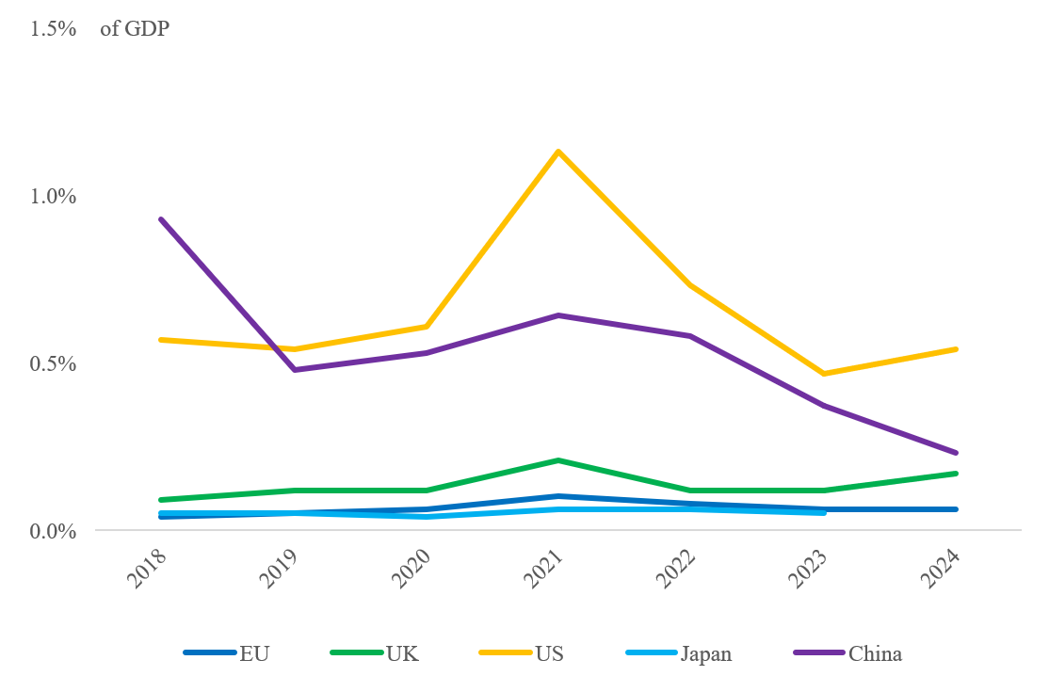
Source: European Commission services based on Invest Europe; Eurostat; OECD; Statista
National data, % of GDP (2024)
AT | BE | BG | CY | CZ | DE | DK | EE | EL | ES | FI | FR | HR | HU
0.03 | 0.08 | 0.03 | 0.01 | 0.01 | 0.07 | 0.13 | 0.20 | 0.01 | 0.06 | 0.09 | 0.07 | 0.02 | 0.02
IE | IT | LT | LU | LV | MT | NL | PL | PT | RO | SE | SI | SK | EU
0.05 | 0.03 | 0.03 | 0.01 | 0.00 | 0.02 | 0.11 | 0.01 | 0.02 | 0.00 | 0.11 | 0.01 | 0.02 | 0.06

KPI 21: EU investments supporting the industrial transition
KPI 21 shows the cumulative volume of InvestEU investments supporting industry’s green and digital transition since the programme became operational in 2021.
This KPI tracks progress against the objective laid down in the Clean Industrial Deal of increasing the cumulative volume of investment supporting industrial the transition from EUR 52.7 billion (value as of June 2024).
As of June 2025 EU investments supporting the industrial transition amounted to EUR 115.5 billion.

Figure 21: EU investments supporting the industrial green and digital transition.
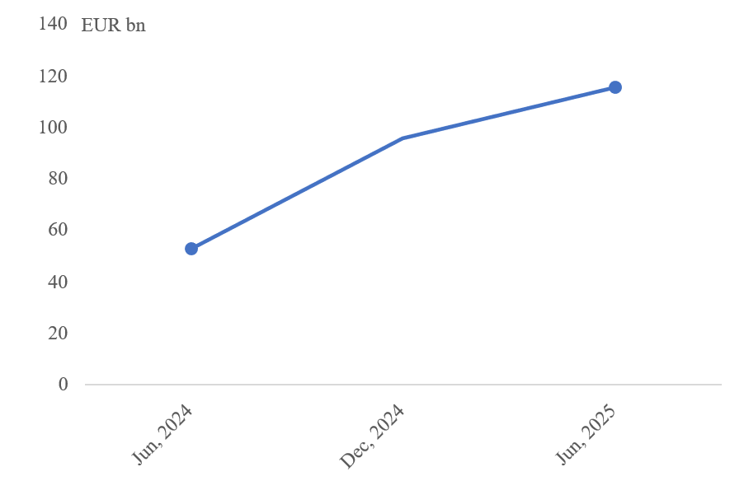
Source: European Commission services, InvestEU indicators

KPI 22: Electricity prices for businesses
KPI 22 tracks non-household retail electricity prices in the EU, US, UK and Japan. It gives an idea of energy costs and cost-competitiveness, especially for industries where electricity prices make up a significant proportion of total energy costs.
Non-household retail electricity prices in the EU are broken down into two consumption bands. Prices are measured in EUR per kWh, excluding value added tax and other duties that companies can recover.
The IC consumption band covers medium-sized consumers with an annual consumption of between 500 MWh and 2 000 MWh, i.e. the vast majority of small-sized companies in services and manufacturing sectors, and gives an insight into affordability.
The ID consumption band covers large consumers with an annual consumption of between 2 000 MWh and 20 000 MWh, such as companies in electricity-intensive manufacturing sectors, and gives an insight into their international competitiveness.
In the first semester of 2025, electricity prices for large industrial users in the ID band were EUR 0.16 /KWh. This is lower than the peak seen in 2023, but since then electricity prices have seemingly stabilised at historically high levels, 50% higher than 2020 levels. By contrast, US prices remained around EUR 0.07 /KWh over this period.
Figure 22: Electricity prices for businesses.
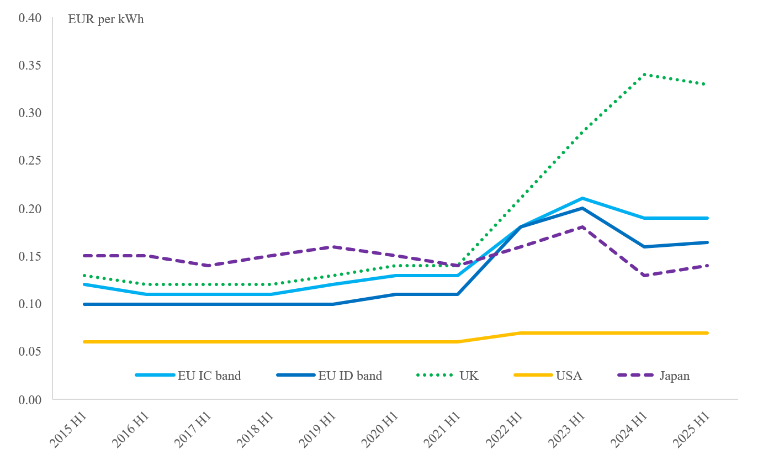
Source: Eurostat; US Energy Information Administration; UK Department for Energy Security and Net Zero; International Energy Agency (2025)
National data (2025) – ID price band (EUR/kWh)
AT | BE | BG | CY | CZ | DE | DK | EE | EL | ES | FI | FR | HR | HU
0.18 | 0.17 | 0.12 | 0.23 | 0.17 | 0.19 | 0.13 | 0.13 | 0.18 | 0.13 | 0.07 | 0.13 | 0.20 | 0.19
IE | IT | LT | LU | LV | MT | NL | PL | PT | RO | SE | SI | SK | EU
0.23 | 0.20 | 0.13 | 0.15 | 0.11 | 0.12 | 0.18 | 0.17 | 0.12 | 0.16 | 0.08 | 0.15 | 0.18 | 0.16

KPI 23: Electrification rate
KPI 23 shows the consumption of electricity as a share of the final energy consumption. Final energy consumption is the total energy consumed by end users, such as households, industry, agriculture and transport (including Intra-EU aviation, but excluding international aviation). It excludes energy used in transformation processes, fuels used for non-energy purposes and energy used by the energy sector.
This KPI tracks progress against the objective laid down in the Clean Industrial Deal of increasing the economy-wide electrification rate to 32% by 2030.
The share of electrification has remained unchanged at around 23% over the last decade.

Figure 23: Evolution of the EU average electrification rate.
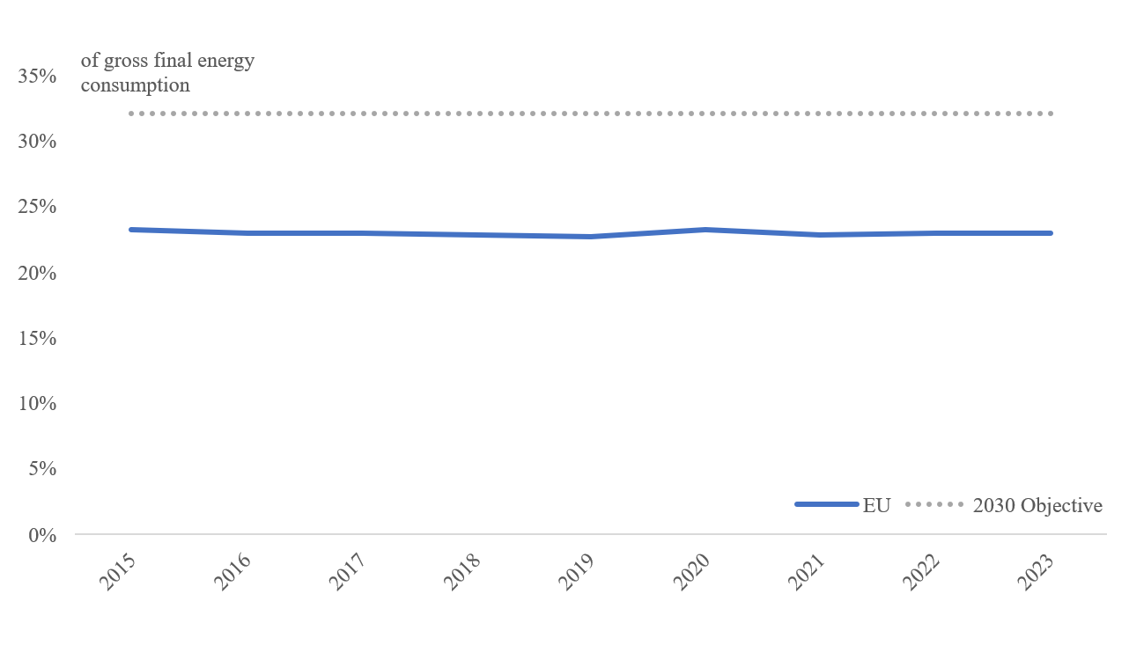
Source: Eurostat
National data, % (2023)
AT | BE | BG | CY | CZ | DE | DK | EE | EL | ES | FI | FR | HR | HU
22.3 | 21.7 | 27.1 | 26.1 | 21.3 | 21.7 | 20.2 | 22.6 | 26.6 | 24.7 | 28.4 | 26.7 | 20.3 | 21.5
IE | IT | LT | LU | LV | MT | NL | PL | PT | RO | SE | SI | SK | EU
24.5 | 22.2 | 16.5 | 17.8 | 14.3 | 39.7 | 23.0 | 16.6 | 25.9 | 15.4 | 33.2 | 23.5 | 19.9 | 23.0

KPI 24: Energy from renewable sources
KPI 24 tracks the share of energy from renewable sources as a share of the total (final) energy consumption in the EU, US, UK, Japan and China.
Renewable energy generation accounted for 25.2% of total energy consumption in 2024. Progress has been strong in the electricity sector, with the share of renewables increasing from 37.4% in 2020 to 47.5% in 2024. Progress was more limited in heating and cooling sector (rising from 23.0% to 26.7%) and transport sector (from 10.3% to 11.%).

Figure 24: Share of renewable energy in the EU and other advanced economies.
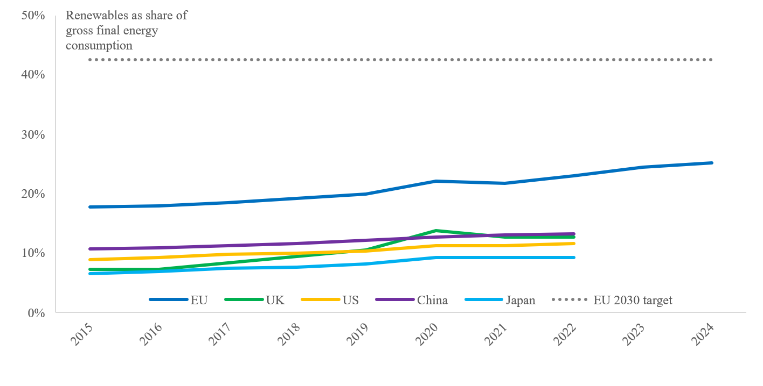
Source: Eurostat; European Commission services
National data, % (2024)
AT | BE | BG | CY | CZ | DE | DK | EE | EL | ES | FI | FR | HR | HU
43.0 | 14.3 | 23.2 | 21.9 | 19.2 | 22.5 | 46.8 | 41.0 | 25.3 | 25.4 | 50.7 | 23.2 | 27.5 | 18.3
IE | IT | LT | LU | LV | MT | NL | PL | PT | RO | SE | SI | SK | EU
16.1 | 19.3 | 35.4 | 14.7 | 45.5 | 17.2 | 20.2 | 17.7 | 36.5 | 25.4 | 62.8 | 24.6 | 18.1 | 25.2

KPI 25: Annual growth in renewable electricity generation
KPI 25 measures the annually added capacity (in GW) to generate renewable electricity.
This KPI tracks progress against the objective laid down in the Clean Industrial Deal of installing at least 100 GW of new renewable energy per year.
The capacity added every year to generate renewable electricity has been accelerating: it was around 68 GW in 2024, more than double the value of 2020.

Figure 25: Annual growth in EU installed renewable electricity generation capacity.
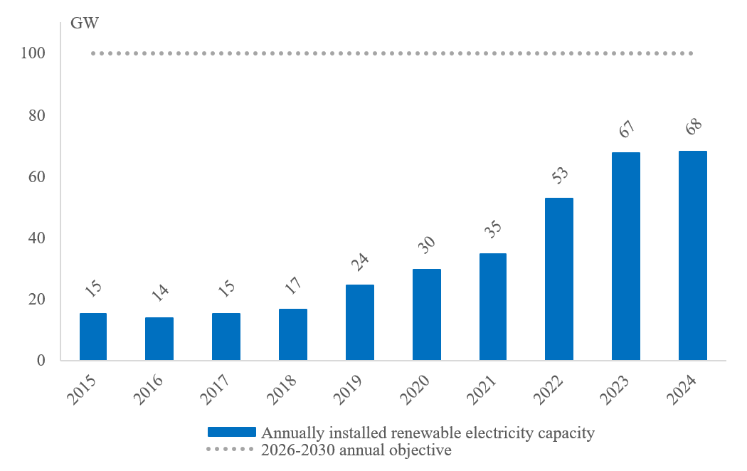
Source: European Commission services. The objective refers to yearly capacity needed in the next 5 years to reach the 2030 renewable energy target.

Increasing security and reducing dependencies

KPI 26: Trade with the rest of the world
KPI 26 tracks the EU’s degree of economic integration with the rest of the world by measuring trade flows in goods and services with the rest of the world as shares of total EU GDP. Trade is measured by the average of imports and exports.
The long-term trend shows growing trade integration with the rest of the world, but there are signals pointing towards a slow-down or even a reversal. EU trade in goods with the rest of the world continued to decline for the second year in row. The average of extra-EU imports and exports of goods corresponded to 13.9% of GDP in 2024. While it can to some degree be attributed to energy price fluctuations, it also shows the trend of a deteriorating global trading climate. EU trade integration in services with the rest of the world has equally slowed but remains on an increasing trajectory.

Figure 26: EU trade in goods and services with the rest of the world as shares of GDP.
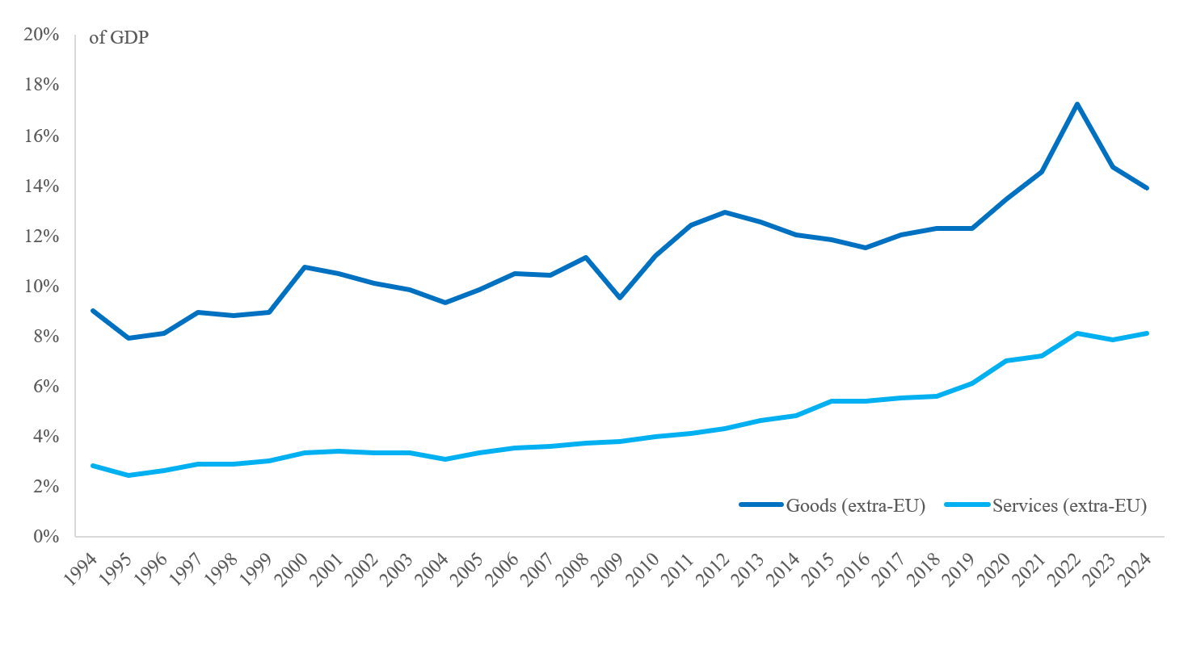
Source: Eurostat

KPI 27: The EU economy’s global market share
KPI 27 tracks the EU economy’s global market share by measuring EU exports in goods and services as shares of total global imports.
Figures 27a and 27b show the exports of goods and services of the EU, US, UK, Japan and China as shares of global imports. They show the relative size of exports from the EU and from those four countries in the global market. A higher percentage indicates a greater role in the global economy, and a lower percentage indicates a smaller global market share.
The EU’s share in global trade remains stable, but pressure on the manufacturing industry is building up. EU exports of goods as a share of global imports stand slightly above the levels of 10 years ago and shows remarkable resilience.
For exports of services, the outlook is more encouraging, despite a small decline over the last year, with the past 10 years having seen the EU’s global market share grow to reach 25% of global trade in services, cementing the EU’s position as the top global exporter of services.
Figure 27a: Exports of goods as a share of total global imports.
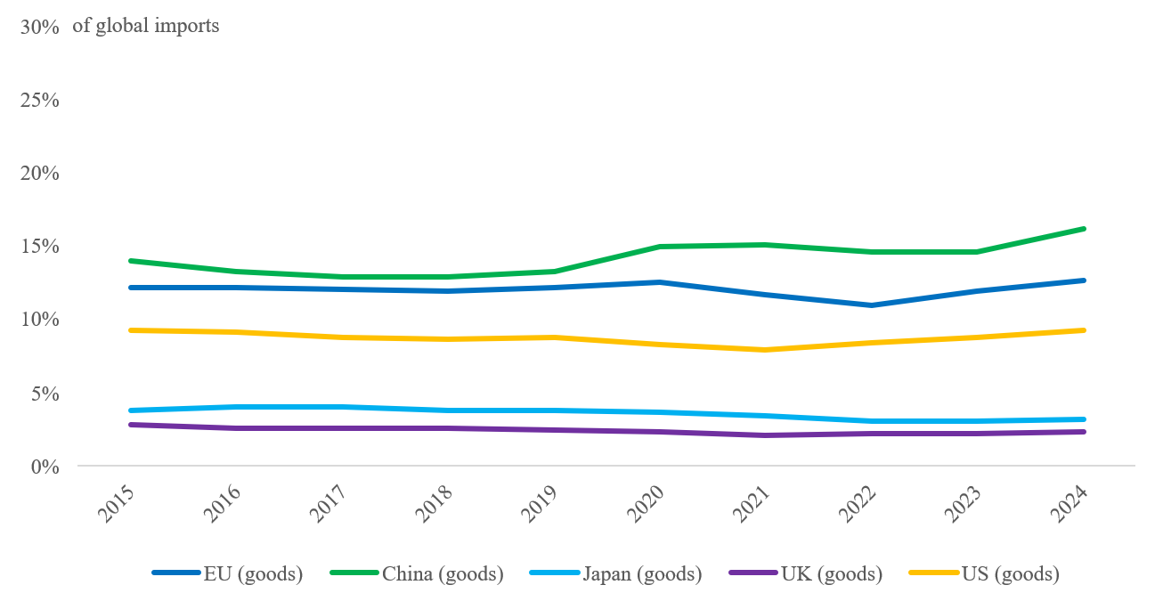
Figure 27b: Exports of services as a share of total global imports.
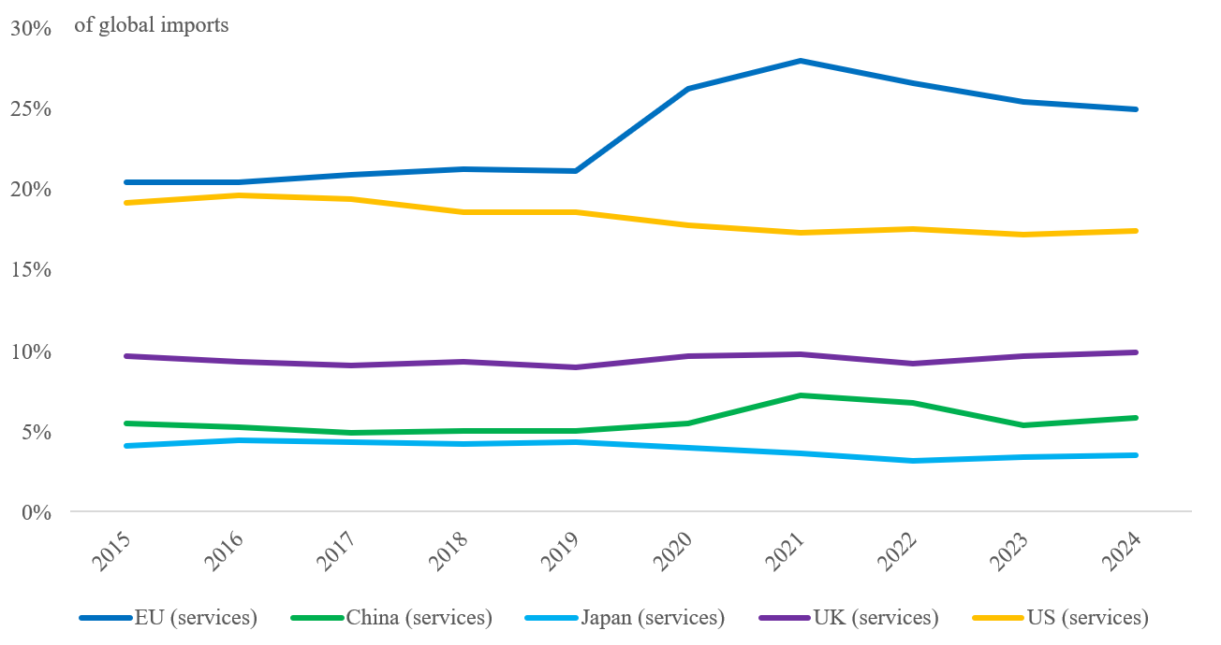
Source: Eurostat

KPI 28: Domestic clean tech manufacturing capacity
KPI 28 measures the share of clean tech components tracked under the Net-Zero Industry Act that meet the benchmark of meeting 40% of EU consumption by domestic manufacturing. The objective is for 100% of components to reach this benchmark.
This KPI tracks progress against the objective laid down in the Clean Industrial Deal of increasing the domestic manufacturing capacity for clean tech products.
Looking at products within the scope of the Net-Zero Industry Act, EU manufacturing currently surpasses the benchmark of meeting 40% of EU consumption by domestic manufacturing in 6 of the 27 (22%) monitored technology areas. However, for the vast majority of monitored key components in battery technologies, electrolysers, hydrogen and solar, EU manufacturing capacity still significantly trails the benchmark. The situation is particularly concerning in battery technologies where the EU has no capacity to manufacture anode active materials and can only meet 4% of EU domestic demand for cathode active materials.

Figure 28: Domestic clean tech manufacturing capacity: Status on the way towards the 2030 benchmark manufacturing rate.
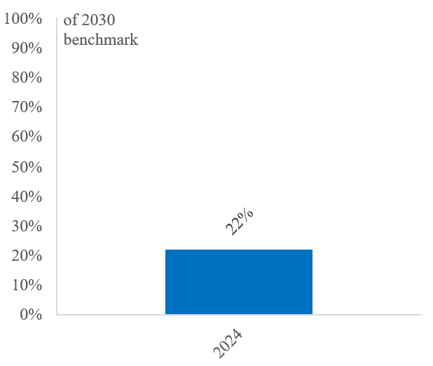
Source: European Commission services

KPI 29: External vulnerability
KPI 29 assesses the combined vulnerability to external shocks of strategically important industrial products. The selected products include semiconductors, net-zero technologies, raw materials, basic metals, chemicals, machinery and motor vehicles. The index quantifies the degree of vulnerability using scores that range from 0 (low vulnerability) to 1 (high vulnerability) and it is built on two pillars: (i) the risks from foreign dependencies, examining the concentration of trade flows and reliance on foreign markets, and (ii) risks from a weak global market position, evaluating competitive strengths and weaknesses through price differences and relative comparative advantages.
This KPI tracks progress against the objective laid down in the Clean Industrial Deal of decreasing the EU’s external vulnerability.
Europe’s supply chains continue to show a significant degree of external dependencies, which carry the risk of being weaponised. An analysis has identified 204 products in sensitive ecosystems where the EU is heavily dependent on a single supplier country, and which could therefore be disrupted by an external shock. Among these products, more than half of the EU’s dependencies originate from China. The EU’s overall dependence on imports of key industrial products remains largely unchanged. Analysis of trade data for industrial products shows that the EU is significantly more exposed to external vulnerabilities than China, but less exposed than the US. Zooming in on strategically important industrial products, China has the lowest degree of external dependency with an EXVI score of 0.12, with the EU at 0.20 and the US at 0.28.

Figure 29: External vulnerability, measured by the EXVI index.

Source: European Commission servicesservices calculations (DG GROW Chief Economist Team) ; Single Market Economics Briefs: EXternal Vulnerability Index (2025)

Annex 2

Implementation trackers

A Competitiveness Compass for the EU (adopted on 29 January 2025)
The expected timelines of actions have been updated in view of most recent developments.
Status | Pillar 1 – Closing the innovation gap | Timeline
 | Start-up and scale-up strategy | 28 May 2025
 | 28th regime (EU Inc.) | Q1 2026
 | European Innovation Act | Q1 2026
 | European Research Area Act | Q3 2026
 | AI continent action plan | 9 April 2025
 | Apply AI strategy | 18 October 2025
 | AI in science strategy | 18 October 2025
 | Data Union strategy | 19 November 2025
 | EU Cloud and AI Development Act | Q1 2026
 | Quantum Europe strategy | 2 July 2025
 | Quantum Act | Q2 2026
 | European Biotech Act (Part I) | 16 December 2025
 | European Biotech Act (Part II) | Q3 2026
 | Bioeconomy strategy | 27 November 2025
 | Life Sciences strategy | 2 July 2025
 | Advanced Materials Act | Q4 2026
 | Space Act | 25 June 2025
 | Review of the EU merger guidelines | Q4 2026
 | Digital Networks Act | 21 January 2026
Status | Pillar 2 – A joint roadmap for decarbonisation and competitiveness | Timeline
 | Clean Industrial Deal | 26 February 2025
 | Action plan for affordable energy | 26 February 2025
 | Industrial Accelerator Act | Q1 2026
 | Electrification action plan | Q1 2026
 | European grids package | 10 December 2025
 | Clean Industrial Deal State aidframework (CISAF) | 25 June 2025
 | Steel and metals action plan | 19 March 2025
 | Chemicals industry package: (1) Action plan for the chemicals industry … | 8 July 2025
 | … and (2) Simplification Omnibus VI on chemicals | 8 July 2025
 | Strategic dialogue on the future of the European automotive industry | 30 January 2025
 | Industrial action plan for the European automotive sector | 5 March 2025
 | Sustainable transport investment plan | 5 November 2025
 | European port strategy and industrial maritime strategy | Q1 2026
 | High-speed rail action plan | 5 November 2025
 | Review of the Carbon Border Adjustment Mechanism (CBAM) | 17 December 2025
 | Circular Economy Act | Q3 2026
 | Vision for agriculture and food | 19 February 2025
 | Oceans Pact | 5 June 2025
 | Amendment of the Climate Law | 2 July 2025
Status | Pillar 3 – Reducing excessive dependencies and increasing security | Timeline
 | Conclude and implement ambitious trade agreements, clean trade and investment partnerships | Ongoing
 | Trans-Mediterranean Energy and Clean Tech Cooperation initiative | Q4 2025
 | Joint purchasing platform for Critical Raw Minerals | 2 July 2025
 | Revision of directives on public procurement | Q2 2026
 | White Paper for European Defence | 19 March 2025
 | Preparedness Union strategy | 26 March 2025
 | Internal security strategy | 2 April 2025
 | Critical Medicines Act | 11 March 2025
 | European climate adaptation plan | Q4 2026
 | Water Resilience Strategy | 4 June 2025
Status | Horizontal enablers of competitiveness | Timeline
 | (1) Definition of small mid-caps (SMCs) … | 21 May 2025
 | … and (2) Simplification Omnibus IV on small mid-cap companies, digitalisation and common specifications | 21 May 2025
 | European business wallet | 19 November 2025
 | Single Market strategy | 21 May 2025
 | Revision of the Standardisation Regulation | Q3 2026
 | Savings and Investments Union | 19 March 2025
 | Proposal for the multiannual financial framework (MFF) 2028-2034, including the Competitiveness Fund | 16 July 2025 and 3 September 2025
 | Competitiveness coordination tool | Q1 2026
 | Union of Skills | 5 March 2025
 | Quality jobs roadmap | 4 December 2025
 | Skills Portability Initiative | Q3 2026

Proposal adopted / For legal proposals, indicates adoption by both the European Parliament and the Council |   Legal proposal presented by the Commission and currently under adoption by the European Parliament and the Council

The Clean Industrial Deal: A joint roadmap for competitiveness and decarbonisation (adopted on 26 February 2025)
The expected timelines of the actions have been updated in view of most recent developments.
Status | Access to affordable energy and infrastructure | Timeline
 | Action Plan on Affordable Energy | 26 February 2025
 | EIB pilot offering financial guarantees for PPA offtakers, with a focus on SMEs and energy-intensive industry | 20 June 2025
 | Legislative proposal on the extension of the Gas Storage Regulation | 5 March 2025
 | Clean Industrial Deal State aid framework (CISAF) | 25 June 2025
 | Recommendation on network charges | 2 July 2025
 | Industrial Accelerator Act:  - speed-up permitting for industrial access to energy and industrial decarbonisation | Q1 2026
 | Recommendation on energy taxation | Q1 2026
 | Guidance on CfD design, including on combining CfDs and PPAs | 10 Decemeber 2025
 | Guidance on promoting remuneration of flexibility in retail contracts | Q1 2026
 | European Grids Package | 10 December 2025
Status | Lead markets: boosting clean supply and demand | Timeline
 | Delegated act on low carbon hydrogen, providing regulatory certainty to producers of low carbon hydrogen | 8 July 2025
 | Industrial Accelerator Act:  - create a low-carbon product label  - apply sustainability, resilience and minimum EU content requirement to public and private-sector procurement in strategic areas to ensure lead markets for low-carbon products | Q1 2026
 | Communication and legislative proposal on greening corporate fleets | 16 December 2025
 | Revision of Public Procurement Directives to mainstream the use of non-price criteria | Q2 2026
Status | Public and private investment | Timeline
 | Increase InvestEU’s risk bearing capacity as part of the simplification Omnibus II on investment | 26 February 2025
 | IPCEI Design Support Hub | 9 April 2025
 | Clean Industrial Deal State aid framework | 25 June 2025
 | Recommendation to Member States to adopt tax incentives to support the Clean Industrial Deal | 2 July 2025
 | Flagship call for proposals under the Horizon Europe programme | 11 December 2025
 | Pilot auction under the Innovation Fund for industrial decarbonisation | 10 October 2025
 | Industrial Decarbonisation Bank | Q2 2026
 | TechEU investment programme on scale-ups with the EIB Group and private sector | 20 June 2026
Status | Powering the circular economy: a secure access to materials and resources | Timeline
 | First list of Strategic Projects under the Critical Raw Materials Act | 25 March 2025 & 4 June 2025
 | Ecodesign for Sustainable Products and Energy Labelling Working Plan 2025–2030 | 16 April 2025
 | EU Critical Raw Materials Centre for joint purchases and management of strategic stockpiles | Q2 2026
 | Circular Economy Act | Q3 2026
 | Green VAT initiative | Q4 2026
 | Trans-Regional Circularity Hubs | Q4 2026
Status | Global markets and international partnerships | Timeline
 | Launch negotiations for the first Clean Trade and Investment Partnership | 13 March 2025
 | Simplification of the Carbon Border Adjustment Mechanism (CBAM) as part of the simplification Omnibus I on sustainability | 26 February 2025
 | Comprehensive CBAM review assessing the feasibility of extending the CBAM scope to other EU ETS sectors at risk of carbon leakage, to downstream sectors and to indirect emissions and support to exporters, closing loopholes | 17 December 2025
 | Trans-Mediterranean Energy and Clean tech cooperation initiative | Q4 2025
 | Legislative proposal on an extension of the CBAM | 17 December 2025
 | Guidelines on the Foreign Subsidies Regulation | 9 January 2026
Status | Skills and quality jobs for social fairness | Timeline
 | Union of Skills | 5 March 2025
 | Quality Jobs Roadmap | 4 December 2025
 | European Fair Transition Observatory | Q1 2026
 | Skills Portability Initiative | Q3 2026
 | Review of State aid GBER rules for social enterprises and for the recruitment of disadvantaged workers | Q4 2026

Proposal adopted / For legal proposals, indicates adoption by both the European Parliament and the Council | Legal proposal presented by the Commission and currently under adoption by the European Parliament and the Council

The Single Market Strategy (adopted on 21 May 2025)
The expected timelines of actions have been updated in view of most recent developments.
Status | Chapter 1. Removing barriers: Doubling down on the ‘Terrible 10” | Timeline
 | Simplification Omnibus VII on digital | 19 November 2025
 | Simplification Omnibus VIII on environmental rules | 10 December 2025
 | Competitiveness check as core part of impact assessment | Ongoing
 | Review of national and European agencies in the field of the Single Market | Q3 2026
 | Public Procurement Act | Q2 2026
 | Revision of Directive on defence and sensitive security procurement | Q3 2026
 | First meeting of high-level Single Market Sherpas | Q1 2026
 | First SMET annual high-level political meeting | 8 December 2025
 | Single Market Barriers Prevention Act (if necessary) | Q3 2027
 | 28th Regime for Innovative Companies (EU Inc.) | Q1 2026
 | Revision of Commission Recommendation on business transfers | Q1 2026
 | Exploring EU legislation to address barriers to the mobility of workers | Ongoing
 | Measures on professional qualifications as part of Skills Portability Initiative | Q3 2026
 | Explore EU legislation to establish common rules for the recognition and validation of qualifications and skills of third country nationals | Q3 2026
 | Establishing common specifications when needed as part of the simplification Omnibus IV | 21 May 2025
 | Update of rules on standardisation | Q3 2026
 | Revision of Textile Labelling Regulation | Q2 2026
 | Circular Economy Act | Q3 2026
 | European Product Act | Q3 2026
 | Facilitate provision of pan-EU services by providers authorised or certified in one MS on basis of EU law | Q4 2026
 | Legal guidance and recommendations to MS to provide clarity on the right to provide services cross-border on a temporary basis | Q4 2026
 | Support of co-legislators to conclude negotiations on the revision of Regulations (EC) Nos 883/2004 and 987/2009 on social security coordination | Ongoing
 | Support of co-legislators to conclude negotiations on the proposal for a public interface for the declaration of posting of workers | Ongoing
 | Fair Labour Mobility Package | Q3 2026
 | Tools to act against unjustified Territorial Supply Constraints | Q4 2026
Status | Chapter 2. Boosting European Services Markets | Timeline
 | Construction Services Act | Q4 2026
 | European Strategy for Housing Construction | 16 December 2025
 | Initiative to facilitate the cross-border provision of industry-related services such as installation, maintenance, repair | Q4 2026
 | Guidance and recommendations to Member States to free regulated business services from unnecessary regulation | Q4 2026
 | Guidance to MS on the proportionality of their retail regulation | Q4 2026
 | EU Delivery Act | Q3 2026
 | Digital Networks Act | 21 January 2026
 | Initiative for single digital booking and ticketing for rail | Q2 2026
 | Initiative for paperless mobility for passengers and goods | Q4 2026
 | Initiative on cross-border car rentals | Q2 2026
 | Ensuring harmonised implementation and enforcement of the EU Services Directive | Ongoing
Status | Chapter 3. SMEs in the Single Market | Timeline
 | SME ID tool based on self-declaration available in all EU languages | 21 May 2025
 | Reinforcement of the Network of SME Envoys | Q4 2025
 | Publication of best practice examples of SME-friendly provisions | Q1 2026
 | Definition of small mid-caps (SMCs) | 21 May 2025
 | Extension of certain SME benefits to SMCs as part of the simplification Omnibus IV | 21 May 2025
 | Extension of the existing SME fund, implemented by the EUIPO, for 2026 and possibly 2027 | 17 September 2025
 | Commission Recommendation for a ‘Voluntary SME’ standard | 30 July 2025
 | Development of voluntary streamlined approach to help SMEs demonstrate their sustainability efforts and improve their access to sustainable finance | Ongoing
Status | Chapter 4. Digitalising the Single Market | Timeline
 | European Business Wallet | 19 November 2025
 | EU Digital Identity Wallets roll-out | Q4 2026
 | Revision of IMI Regulation | Q4 2026
 | Digitalisation of declarations of conformity as part of the simplification Omnibus IV | 21 May 2025
 | Revision of the EU acquis on e-Invoicing in public procurement | Q4 2026
Status | Chapter 5. Enforcing respect of Single Market rules | Timeline
 | Strengthening of national SOLVIT centres and whole network | Q4 2025
 | Systematic follow-up by the Commission and the Member States on structural issues identified by SOLVIT and on barriers, where SMET efforts have not been successful | As of Q2 2025
 | First Annual Single Market enforcement agenda | 29 January 2026

Proposal adopted / For legal proposals, indicates adoption by both the European Parliament and the Council | Legal proposal presented by the Commission and currently under adoption by the European Parliament and the Council

Annex 3

Overview of resilience measures by selected global players

Introduction

In 2025, a significant number of the EU’s main trading partners announced policy measures and partnerships aimed at bolstering the resilience of supply chains. The accompanying international annex provides a non-exhaustive list of such measures, which only partially capture the full range of resilience efforts undertaken by partner countries throughout the year. The range and substance of the measures found reflect a global drive to improve supply chain resilience and economic security. The EU’s trading partners have adopted these measures in response to recent global shifts in trade policies and economic strategies, particularly in the United States, and to the weaponisation of dependencies, for example export restrictions announced by China.
The critical raw materials sector is illustrative of the broader action taken to enhance supply chain resilience in 2025. Over the last 15 years, there has been an increase in restrictions within this sector, largely driven by export restrictions on rare earth elements and microchips imposed by China, coupled with geopolitical shifts in the US.
Figure 1: Number of exported raw materials subject to at least one export restriction measure
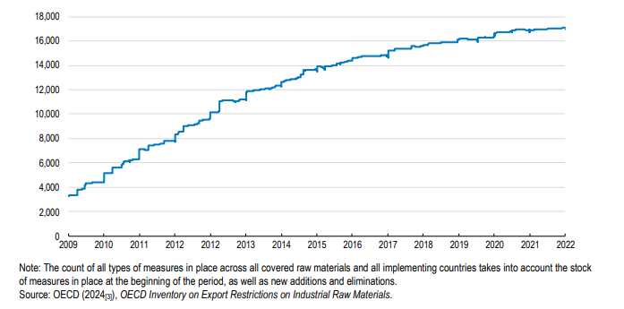
Source: OECD Report on Economic Security in a Changing World
This trend extends beyond the critical raw materials sector. Recent years have seen a proliferation of policies aimed at strengthening supply chain resilience. This emphasises the importance of deepening our understanding of policy developments in this area, and the urgent need for the EU to develop a foreign policy that aligns with its Single Market.
Figure 2: Number of trade policy measures and rationale, by year
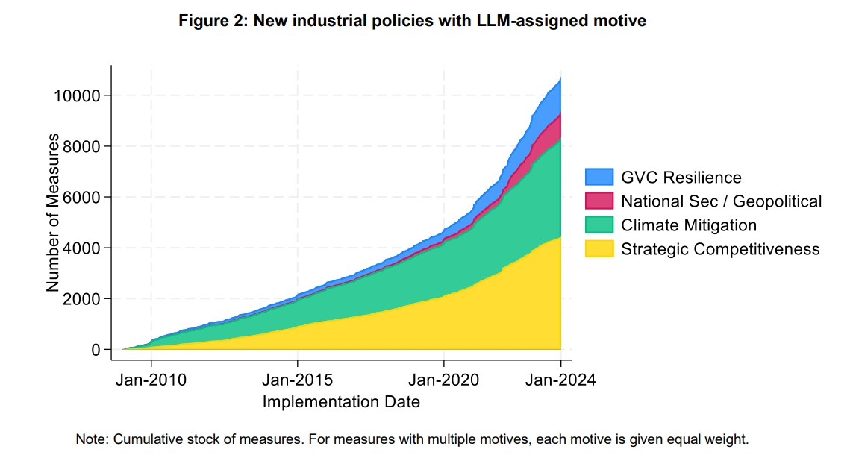
Source: IMF Working Paper on Industrial Policy since the Great Financial Crisis
The aim of this Annex is to give a non-exhaustive picture[2] of the main policy measures and international partnerships adopted by some of the EU’s main international partners to reduce their strategic dependencies and to make their supply chains more resilient, especially in view of the digital and green transitions.
Gaining a better understanding of the methods used by these key international partners to strengthen their supply chains can help the EU to safeguard its critical supply chains and increase its open strategic autonomy. The information in this Annex also sheds light on measures that could potentially expose EU supply chains to risks by, for example, encouraging delocalisation and future disinvestment decisions.
In this 2025 edition, the inventory below lists the main resilience measures taken by some of the EU’s main trading partners (the United States, the United Kingdom, Canada, Japan, China, Singapore, the Republic of Korea, India, Australia, Brazil, South Africa, Vietnam and Taiwan) that the Commission is aware of at the time of adopting this document, reflecting the level of information available for each partner. Therefore, the actual number of resilience measures adopted by international partners could be far greater.
After examining the collected data, the Commission has classified the measures taken by these trading partners into six specific categories with a more detailed description provided for the most recently adopted measures. In each category and for each international partner, the measures are listed and grouped thematically whenever possible – from broader, usually cross-sectoral measures to sector- or product-specific measures, for example:
1. industrial strategies, regulatory measures and crisis preparedness;
2. financial and fiscal support (including R&D);
3. public procurement and prioritisation mechanisms of domestic supply of goods and services;
4. trade toolbox (i.e. tariffs, export restrictions, anti-coercion measures, foreign direct investment control, etc.);
5. international deals and partnerships.
These categories have been chosen as they mirror the policy instruments used internally and externally by the EU to make supply chains more resilient and diverse and to anticipate, prepare for and respond to disruptions. Their scope is deliberately granular to easily classify and regroup together non-EU country measures according to each policy’s rationale and objectives.
The evidence collected in this non-exhaustive annex shows that the EU’s main partners have announced a significant number of new international partnerships and agreements. They focus not only on trade and market access but also on specific sectors such as critical raw materials, clean energy and AI. In addition, several new trade measures have been introduced, including stricter foreign investment screenings, tariff quotas on strategic sectors, as well as the initiation of anti-dumping investigations. The adoption of these measures reflects the changing dynamics in geopolitics and international trade.
In parallel, several trading partners have implemented policies to support their domestic industries, notably through public procurement. These policy measures include public investments and prioritising supply in strategic sectors, such as energy-intensive industries like steel. In this context, international partners have adopted additional domestic measures such as financial support, fast-track regulatory permitting and improved crisis preparedness by stepping up the monitoring and stockpiling of critical minerals.

Overview of resilience measures by category and by countries

2.1 Industrial strategies, regulatory measures and crisis preparedness

United States
- In November 2025, the United States published an updated List of Critical Minerals. The new list includes 60 mineral commodities, of which 10 were new additions to the previous list. Some minerals were included based on the results of the economic effects assessment; others were included because of the potential for a single point of failure within the domestic supply chain and based on a qualitative evaluation.
- In October 2025, the US Department of Defence announced plans to acquire up to USD 1 billion worth of critical minerals, including cobalt, antimony and rare earth elements. The plan aims to mitigate supply chain vulnerabilities and ensure the availability of essential materials for defence and advanced technologies.
- In October 2025, the US Department of Energy released its Fusion Science and Technology Roadmap, a national strategy to accelerate the domestic development and commercialisation of fusion energy. The roadmap focuses on i) building critical infrastructure to close fusion materials and technology gaps; ii) innovating through advanced research, high-performance computing and artificial intelligence; and iii) growing the US fusion ecosystem through public-private partnerships, regional manufacturing hubs and workforce development.
- In August 2025, the US President signed an Executive Order on ‘Unleashing American Energy’ to review, rescind or revise regulations that unduly burden domestic energy and mineral production and expedite the permitting of energy and infrastructure production. The Executive Order also annuls previous Executive Orders related to climate policy, including state waivers and subsidies aimed at encouraging EV purchases. It states that the US should encourage energy exploration and production on federal lands, boosting US leadership in critical minerals and ensuring a reliable supply of energy.
- In August 2025, the US announced the creation of a stockpile of pharmaceutical drugs and a critical drugs list. Executive Order 14336 on Ensuring American Pharmaceutical Supply Chain Resilience by Filling the Strategic Active Pharmaceutical Ingredients Reserve seeks to strengthen the resilience of the US pharmaceutical supply chain by stockpiling active pharmaceutical ingredients (APIs) for essential medicines within the Strategic Active Pharmaceutical Ingredients Reserve and promoting the domestic production and procurement of these APIs. Under the Order, the Office of the Assistant Secretary for Preparedness and Response within the Department of Health and Human Services is tasked with drawing up a list of approximately 26 critical drugs deemed essential to national health and security.
- In July 2025, the Department of Interior announced the launch of a programme to map mining waste deposits to recover critical minerals – including rare earth elements (REEs), germanium, tellurium, antimony, and zinc – from mine waste, coal refuse and abandoned uranium sites. The programme follows the US Department of the Interior’s Order No 3436 which seeks to accelerate the extraction of critical and strategic minerals from mine waste across the United States.

United Kingdom
- In June 2025, the UK Department for Business and Trade published the UK’s Modern Industrial Strategy for 2025. The actions mentioned in the strategy include cutting electricity costs, reducing grid connection times, providing finance for innovative business, enhancing investor support to meet business demand for skills, simplifying regulation, boosting research and development (R&D) sending and deepening economic cooperation with partners. It focuses on eight key sectors: advanced manufacturing, clean energy industries, creative industries, defence, digital and technologies, financial services, life sciences, and professional and business services. It consists of a 10-year plan to make it quicker and easier to invest and expand in a more competitive, secure and resilient economy. Following the strategy’s launch, in August and September 2025, six sector plans were published for the advanced manufacturing sector, clean energy industries, creative industries, digital and technologies sector, life sciences sector, and professional and business services sector.
- In February 2025, the UK announced the Plan for Steel, including financial support for the sector. The aim of the Plan is to set out a clear and long-term vision for the steel industry. While the full details are still being developed, the government has committed up to GBP 2.5 billion in support through the National Wealth Fund and other channels.

Japan
- In November 2025, Japan launched the Japan Growth Strategy Headquarters, a policy command centre which aims to revitalise the country’s industrial base and economy with public-private investment. The Headquarters focuses on 17 strategic sectors, including AI, semiconductors, energy security and defence. It is composed of Japan’s Prime Minister, government officials and 12 private-sector experts.
- In May 2025, the Economic Security Action Plan (launched in 2022) was revised adding five new critical areas to monitor in relation to national security and competitiveness. The new areas are fusion energy, manufacturing technologies for nuclear-related materials, satellites and rockets, undersea cables, and industrial-use data.
- In February 2025, the Japanese government decided to revise the legal guidelines of the Economic Security Promotion Act (ESPA), which allows the government to temporarily take over critical factories of goods such as semiconductors during emergencies. The new rule could also come into play if a domestic company, influenced by foreign interests, were to attempt a takeover aimed at acquiring sensitive manufacturing technologies.

Republic of Korea
- In February 2025, the Special Act on National Resource Security came into force. It aims to put in place early warning systems, manage the supply and demand for essential resources, and develop crisis response frameworks in order to tackle resource security challenges. More specifically, the Act outlines the creation of a Resource Security Council, chaired by the Minister of Trade, Industry, and Energy, to coordinate policy efforts; mandates the implementation of an early warning system to track and address resource security threats; requires designated organisations to stockpile key resources; authorises emergency actions such as price controls and resource allocation during crises; and requires the formulation of crisis response manuals alongside regular training exercises.

Singapore
- In April 2025, the Singapore Economic Resilience Task force (SERT) was formed. The SERT is a government task force created to help Singaporean businesses and workers navigate current economic challenges, namely the uncertainties caused by the US tariffs, while developing a long-term strategy. In August 2025, the SERT launched an Economic Strategy Review (ESR). The ESR aims to develop longer-term strategies to strengthen Singapore’s global competitiveness, leverage technology and innovation, nurture entrepreneurship, enhance human capital and manage the impact of restructuring. It involves five committees composed of members of government, private sector, unions and other stakeholders.

Australia
- On 24 April 2025, Australia committed to create a Critical Minerals Strategic Reserve to maximise the strategic value of Australia’s critical minerals. The government allocated AUS 1.2 billion to establish the reserve in the 2025-26 Federal Budget. The reserve is expected to be operational in the second half of 2026. A task force was established in the Department of the Prime Minister and Cabinet to advise the government on the design of the reserve. The task force reports jointly to the Prime Minister and the Minister for Resources and will consult with critical minerals industry associations and businesses, state and territory governments, international partners and other interested stakeholders.

India
- In October 2025, India announced the launch of the National Critical Mineral Stockpile to secure rare earth elements and other critical minerals essential for clean energy, electronics and defence. The government has allocated INR 500 (EUR 48.9 million) under the National Critical Minerals Mission to support this effort, and private-sector participation is encouraged in procurement, storage and release mechanisms. The stockpile will initially hold a two-month reserve of processed rare earths and will later expand to include other strategic minerals. The initiative is designed to act as a buffer against global supply disruptions and price volatility, particularly in response to China’s export controls.

Canada
- In November 2025, Canada announced seven initiatives on energy and critical raw materials to be recommended for fast-track approval. The initiatives are worth a combined CAD 116 billion (EUR 71 billion). The announcement adds to the five projects already announced for fast-tracking in September and follows the launch of the Major Projects Office in August 2025. The aim of this Office is to have a single point of contact to get nation-building projects built faster.
- In June 2025, the One Canadian Economy Act received royal assent, which aims to remove interprovincial trade barriers and accelerate the approval of major ‘nation-building’ projects in an effort to bolster untapped domestic economic potential. The Act includes the Building Canada Act, which streamlines the regulatory process for projects in Canada’s national interest, to be overseen by the Major Projects Office. The second part regards the Free Trade and Labour Mobility in Canada Act, which facilitates the movement of goods, services and workers across provinces, in the absence of a Canadian internal market.

2.2 Financial and fiscal support (including R&D)

United States
- In July 2025, the US President signed the One Big Beautiful Bill Act of 2025 (‘OBBBA’) into law, providing fiscal support to domestic research or experimental (R&E) expenditure and to support the domestic minerals supply chain. Under the OBBBA, full expensing of domestic R&E expenditures is restored, while the treatment of foreign R&E expenditures will continue to be capitalised and amortised over a 15-year period. In addition, the OBBBA introduces new federal spending measures that could support the domestic minerals supply chain, including USD 2 billion to expand the National Defence Stockpile through purchases of critical minerals, and USD 5 billion to the Industrial Base Fund to support critical minerals supply chains. It also includes USD 500 million to grow the Department of Defence Credit Program Account, to provide loans, loan guarantees and technical assistance to critical mineral industries, and USD 1 billion under the Defence Production Act with financing up to September 2027. The final law is applicable to tax years beginning after 31 December 2024.

Canada
- In July 2025, Canada announced a new funding round to support clean energy products. The new round allocates CAD 40 million (EUR 25 million) of funding under its Low-Carbon Economy Fund’s Indigenous Leadership Fund to support 13 indigenous-owned and -led clean energy projects. Projects receiving funding include solar panel installations, wind turbines, energy retrofits, electric vehicle infrastructure and heat pumps. The aim is to cut emissions, reduce energy costs and enhance energy self-sufficiency in indigenous communities. The fund is part of Canada’s efforts to implement Article 29 of the UN Declaration on the Rights of Indigenous Peoples Act, and completements a previous announcement from early July 2025 of CAD 13.3 million (EUR 8.3 million) for five clean economy projects in Alberta and the Northwest Territories, including two indigenous-led initiatives.
- In July 2025, Canada announced financial support to the steel sector. The financial support consists of CAD 1 billion (EUR 609 million) as part of the Strategic Innovation Fund to help steel companies advance projects that will improve their competitiveness and start production of steel products not currently produced in Canada.
- In September 2025, Canada announced a Strategic Response Fund to help firms in all sectors impacted by tariffs to adapt, diversify and grow. The fund totals CAD 5 billion (EUR 3.05 billion) and will concentrate on strategic sectors disproportionately exposed to US tariffs and global trade risks, such as automotive, steel and aluminium. It will also have flexibility to intervene in other high-value sectors where federal action is deemed critical to maintaining investment and capacity in Canada.

United Kingdom
- In February 2025, the UK government pledged to provide GBP 2.5 billion (EUR 3 billion) of financial assistance to support the steel industry. The financial support followed the US announcement of a 25% tariff on steel and aluminium imports and will be provided through the National Wealth Fund.
- In 2025, the UK government announced a series of financial relief measures to support the domestic car industry in response to new 25% US tariffs on UK exports of electric vehicles (EV). These include i) a reduction of fines under the UK’s EV mandate, that sets out the proportion of a manufacturer’s sale that must be EV, from GBP 15 000 to GBP 12 000 per non-compliant vehicle; ii) more flexibility for carmakers to meet EV sales targets by allowing them to balance annual targets up to 2030, thereby deferring fines; and iii) a GBP 2.3 billion support package comprising tax breaks for EV buyers and investment in charging infrastructure.

India
- In September 2025, India approved an INR 1 500 (EUR 147 million) scheme to support the development of recycling of critical minerals. The initiative is conducted under the National Critical Mineral Mission and will cover e-waste, lithium-ion battery recycling and other scrap such as catalytic converters from end-of-life vehicles. The incentive will be available for both expanding and modernising existing facilities and will run for six years. Both larger and smaller firms will be eligible, but one third of the total amount available is reserved for smaller firms.
- In May 2025, India introduced a Scheme to Promote Manufacturing of Electric Passenger Cars in India, in a move to boost domestic electric vehicle (EV) production and to attract global players to establish local value chains. Under the scheme, import duty reductions are available to global automakers that commit to manufacturing in the country. More specifically, up to 8 000 EVs per year can be imported at a reduced 15% duty if the automaker invests at least USD 500 million in local EV production facilities within three years.
- In September 2025, India adopted the India Semiconductor Mission (ISM) 2.0 initiative, which expands financial support to capital equipment and materials in the semiconductor supply chain. Although not officially confirmed, the government was exploring an outlay of USD 20 billion of investment. The previous edition of the India Semiconductor Mission, launched in 2021, aimed to provide financial support for investments in semiconductor fabrication, display manufacturing and chip design. Under this edition, in May 2025, the Indian Union Cabinet provided USD 422 million (INR 3.706) of funding for the establishment of a new semiconductor manufacturing unit in Uttar Pradesh under the India Semiconductor Mission. The plant will specialise in producing display driver chips for mobile phones, laptops, automobiles and personal computers. The approval of the project brings the total number of such approved facilities to six under the India Semiconductor Mission.
- As of March 2025, the Indian government has disbursed EUR 2.1 billion under its Production Linked Incentive schemes. This scheme is designed to help develop local supply chains by inviting foreign companies to set up units in India and encouraging local companies to set up or expand existing manufacturing units and reduce the country’s reliance on imports from other countries. It focuses on 12 key sectors including electronics, IT hardware, pharmaceuticals, bulk drugs, medical devices, automobiles, white goods, telecom, food processing, specialty steel, textiles and drones. The scheme has attracted a total of EUR 17.6 billion in investment, generated EUR 165 billion in production and sales, and created over 1.2 million direct and indirect jobs.

Taiwan
- In April 2025, Taiwan amended the Statute of Industrial Innovation, extending tax reduction incentives to companies in key supply chains. According to the Statute, companies with a critical position in the global supply chain (including those with technological innovations in semiconductors, electric vehicles and 5G) may claim an investment tax credit (‘ITC’) of 25% on R&D expenditure and 5% on procurement of machinery/equipment for advanced processes. Companies may apply to use such ITCs over seven years, from 1 January 2023 to 31 December 2029 (the expiry date of the Statute). The most recent amendments extended the tax incentives for equipment investment, expanded the scope of eligible investment to include AI products and services, energy-saving and carbon-reduction initiatives, and increased the expenditure cap. The amendment also increased the tax incentives for investments in startups and safeguards to prevent critical technology outflows, requiring prior government approval not only for overseas investments but also investments in designated countries, regions, industries or technologies.

Japan
- In October 2025, the Ministry of the Environment (MoE) announced plans to provide financial support for recycling hubs aimed at supplying automotive parts to manufacturers. The plan involves setting up 10 domestic hubs for the collection of recycled plastics. The MoE will supply JPY 974 million to run these hubs, namely to conduct research and support the installation of the facilities needed. The aim is to help private automotive manufacturers meet the mandatory requirements for the use of recycled plastics in vehicles the EU is expected to introduce.
- In September 2025, the Japanese Environment Ministry launched a subsidy scheme for companies and municipalities to promote the instalment of next-generation perovskite solar cells in buildings. The initiative consists of JPY 5 billion from the current year’s budget to cover up to 75% of the costs needed to purchase and install these cells in warehouses, factories and gymnasiums where heavy traditional panels cannot be installed.
- In May 2025, the Japanese Cabinet approved a JPY 900 billion (EUR 5.5 billion) economic support package with total fiscal measures reaching JPY 2.8 trillion (EUR 17.2 billion) including local government spending. The package, brought in as a response to US tariffs, includes JPY 600 billion (EUR 3.7 billion) for energy subsidies, and JPY 300 billion (EUR 1.8 billion) to support SMEs through employment adjustment subsidies, government-backed loans (exploring lower interest rates), and new business consultation centres. JPY 388 billion (EUR 2.3 billion) from reserve funds will subsidise electricity and gas bills, cutting average household costs by JPY 1 000 (EUR 6) per month. The government also extended its gasoline subsidies, which were introduced in 2022, for the tenth time and took action to reduce rice prices.
- In 2025, Japan started updating the Economic Security Promotion Act (ESPA), which is expected to expand support tools for economic security. The revised version is expected to include government funding for overseas expansion (such as port development and dock repairs), support to private-sector projects (such as submarine cable laying and maintenance), an expanded scope of critical infrastructure to medical facilities, the creation of a new think-tank, the setup of a Council for public-private dialogue, the protection of sensitive personal data and the addition of five critical products to the current list of 12 critical products. Specific companies supplying designated critical commodities will therefore continue to receive financial and fiscal support over the medium to long term. Subsidies under the ESPA aim to reduce the risk for private operators and encourage them to enter currently low margin/high-risk businesses and R&D.
- In February 2025, Japan published its GX 2040 vision, which indicate bonds totalling JPY 20 thousand billion for the green transformation (GX). The GX 2040 vision presents a detailed roadmap for medium- to long-term GX initiatives, enhancing investment predictability across public and private sectors. It focuses on specific sectors such as energy and other challenging industries like steel, chemical, paper and cement, alongside advancements in next-generation automobiles and airplanes. In addition to providing financial investment, the vision indicates a gradual move to bring in carbon pricing.

Republic of Korea
- In February 2025, the Republic of Korea launched a ‘key minerals investment council’. The council will identify private-centred key mineral investment projects and establish a comprehensive public-private support system that includes existing support programmes such as investments in the supply chain stabilisation fund, overseas resource development investigation, loans, overseas investment insurance and supply chain consulting support. The aim is to promote joint public-private investment in key minerals at an annual scale of KRW 50 billion. The council includes the Ministry of Trade, Industry and Energy, Ministry of Strategy and Finance, and Ministry of Foreign Affairs, together with public organisations such as the Korea Mine Rehabilitation and Mineral Resources Corporation, local governments, the Export-Import Bank of Korea, the Korea Trade Insurance Corporation, the Korea Energy Agency, and the Korea Trade-Investment Promotion Agency (KOTRA), as well as private associations in the overseas resources industry.
- In February 2025, an amendment to the Restriction of Special Taxation Act was passed, raising tax credit rates and broadening the categories of companies eligible for incentives in strategic technology sectors. The amendment included a proposal to add AI and future transport sectors to the list of national strategic technologies and to raise the tax credit rate for investment in semiconductors by five percentage points. This measure builds on the Special Taxation Act (in effect since 1 January 2023) which sets out a precise list of 150 strategic technologies for which Republic of Korea-based manufacturing companies could receive tax credits, amounting to KRW 937.6 billion (EUR 631.1 million) in 2023. In April 2023, the Ministry of Industry announced that the list would be updated to include 50 extra technologies, bringing the list to 200 items.

Brazil
- On 22 August 2025, Brazil announced the Sovereign Brazil plan. The plan has three pillars and includes strengthening the Brazilian production sector, which includes a BRL 30 billion (EUR 4.79 billion) credit line, extended tax payment deadlines and export incentives to the sectors most affected by US additional duties on Brazilian imports. This credit line will be available for working capital and investments to diversify and strengthen production chains.

2.3 Public procurement and prioritisation measures of domestic supply of goods and services

United States
- In April 2025, the US President signed an Executive Order on Restoring America’s Maritime Dominance to strengthen US domestic maritime capabilities, streamline procurement and reduce regulatory burdens. Key actions include i) expanding the US-flagged commercial vessel fleet to ensure reliable domestic and international shipping capacity; ii) developing a strategy to ensure US leadership in Arctic maritime routes, countering growing foreign presence in the region; and iii) a mandated review by the Secretary of Defence on the retention and mobilisation of the inactive reserve fleet, ensuring assured access to sealift capacity in times of military need.
- In March 2025, the US President signed an Executive Order to accelerate critical mineral production. The order requires relevant agencies to submit project reports within 10 days to the Chair of the National Energy Dominance Council and to propose immediate approvals within 20 days where feasible. Agencies must also identify mineral deposits on federal lands, support leasing agreements with private landowners, and collaborate with companies on mineral development. The order also calls for a mineral production fund to be set up, and for other federal agencies to engage in financing and sales initiatives to advance mineral supply efforts.

Canada
- By November 2025, the Canadian government will bring in a new policy on Prioritising Canadian Materials in Federal Procurement, in the context of the Buy Canadian policy. The first tool introduced by the policy will require suppliers contracting with the federal government to source key materials from Canadian companies in defence and construction procurements exceeding a CAD 20 million threshold. Initially covering steel and softwood lumber, the policy may later be expanded to cover additional materials. The policy is also expected to stress reciprocity, with Canadian suppliers being prioritised along with suppliers from countries that grant Canada the same access through reciprocal trade agreements. The second tool relates to price preferences for Canadian suppliers or suppliers of Canadian goods. The scope is still to be defined but could be limited to certain critical sectors and apply a threshold mechanism.
- In July 2025, Canada announced the Interim Reciprocal Procurement policy, restricting access to Canadian government contracts to countries that have opened their procurement market to Canada. The initial phase will focus on applying the policy based on the location of suppliers, with a second phase determining supplier eligibility based on the origin of the goods and services offered.

India
- In April 2025, India revised its Domestically Manufactured Iron & Steel Products Policy 2025, prioritising domestic sourcing in public procurement. The policy mandates that all government ministries, departments, agencies and their funded projects give priority to domestically manufactured iron and steel products for procurements exceeding INR 500 000. It also prohibits Global Tender Enquiries for such procurements (including capital goods used in production) valued up to INR 2 billion, unless a waiver is granted by the Department of Expenditure. To enforce compliance, the policy brings in self-certification requirements for local content, procurement procedure standards, and an authorisation requirement for bidders representing domestic firms. In addition, a reciprocity clause bans suppliers from countries that exclude Indian firms from their government tenders.

China
- On 30 September 2025, the State Council issued a notice prioritising domestic production in government procurement activities. The notice specifies that domestic products must have a 20% price evaluation preference over non-domestic products in government procurement activities. In addition, to be considered ‘domestic products’, the notice specifies that the cost of its components must reach the specified proportion, and key components and processes must meet the set requirements. It also sets out a five-year transition period during which for each product category the criteria for constituting a ‘domestic product’ will be further defined.

United Kingdom
- In February 2025, the UK’s updated public procurement rules came into effect. The updated rules envisage new economic security powers that make it possible to bar or exclude companies from procurement competitions on national security grounds.

South Africa
- In July 2025, South Africa announced the Public Procurement Bill, which mandates local production and content requirements in public procurement. Under Article 20, the Bill specifically mandates local production and content requirements in specific sectors. The responsibility for designating these sectors falls to the Minister responsible for trade, industry and competition, who is also charged with setting minimum thresholds and the duration of such designations. This legislation aims to establish a unified framework for procurement, promote the use of technology to improve efficiency and effectiveness, and enhance transparency and integrity to combat corruption.

2.4 Trade toolbox (tariffs, export restrictions, anti-coercion measures, FDI control, etc.)

United States
- Since the beginning of his second term in January 2025, the US President has imposed several tariffs across many sectors and global partners, invoking both the International Emergency Economic Powers Act and Section 232 of the Trade Expansion Act of 1962.
- On 15 January 2025, the US Department of Commerce expanded export controls on advanced computing chips and certain AI model weights. The rule covers high-performance hardware and closed-weight AI models exceeding defined compute thresholds, it requires licences for export or transfer, and extends controls to foreign-produced items derived from US technology. It aims to protect US technological leadership, secure critical supply chains, and prevent the diversion of advanced AI and computing capabilities to adversaries.

Canada
- In July 2025, Canada announced further tariff rate quotas on steel imports. Tariff rate quotas were extended to countries that have a free trade agreement with Canada, with the exception of Mexico and the United States. FTA partners face a tariff quota equalling 100% of 2024 levels, after which a 50% tariff will be applied. Countries that do not have an FTA with Canada face a tariff rate quota equalling 50% of 2024 levels, after which a 50% tariff will be applied. In parallel, Canada introduced Melt and Pour tariffs of 25%, applied on imports from all countries other than the US containing steel melted and poured in China.

Australia
- In August 2025, Australia announced a measure to streamline its anti-dumping processes. Australia transferred the responsibility for safeguard actions to the Anti-Dumping Commission. The reform is intended to make it easier for domestic companies to apply for measures against goods sold below their normal value (dumping) or sold with the aid of foreign subsidies, ensuring a more level playing field for Australian manufacturers facing a surge in imports, particularly in the steel sector.
- In March 2025, the reform of the Defence Trade Control Act 2012 came into force, applying new export restrictions to certain technologies. It includes a ‘deemed export’ offence for supplying sensitive technology to foreign persons within Australia, as well as supplying assistance such as training relating to these technologies.

India
- In September 2025, the Directorate-General of Trade Remedies initiated anti-dumping investigations into solar encapsulants (excluding EVA encapsulants) imported from China, Republic of Korea, Vietnam and Thailand, prompted by a petition from RenewSys India.
- In June 2025, India imposed five-year anti-dumping duties on four chemicals – PEDA (herbicides), Acetonitrile (pharma), Vitamin A Palmitate and Insoluble Sulphur - imported primarily from China, but also from Russia, Taiwan, the EU, Switzerland and Japan. Duties range from INR 481 per tonne to INR 20.87 per kilogram, depending on the product and origin. The move follows recommendations by the Directorate-General of Trade Remedies (DGTR) and aims to safeguard domestic producers from unfairly priced imports.
- In April 2025, India imposed a 12% provisional safeguard duty on certain flat steel imports for 200 days to counteract a surge in low-cost imports, primarily from China, Republic of Korea and Japan. The duty applies to specific steel products, including hot-rolled coils, sheets and plates, but exempts imports priced above certain thresholds to ensure access to high-end products that are not readily available domestically. The DGTR recommended this measure following an investigation that identified significant injury to domestic producers due to the sharp increase in imports.
- In April 2025, the Indian Ministry of Commerce issued an alert to customs authorities to maintain strict vigilance on imports and exports. The aim is to prevent trade from being diverted through India, which could lead to an artificial surge in imports and threaten domestic industry. Customs officials have been instructed to monitor for unusual spikes in trade flows, particularly from China and ASEAN countries, and ensure India is not misused as a transit hub. The alert was announced amid concerns over the re-routing and dumping of Chinese goods following the imposition of sweeping US tariffs on China.

China
- In October 2025, China announced an expansion of its rare earth export controls, adding five new rare earth elements, expected to come into effect on 8 November 2025. In addition, the new export controls include extraterritorial provisions, requiring export licences for products made outside China if they contain Chinese-origin materials or are produced using Chinese technologies.
- In April 2025, China imposed new export licensing requirements on seven medium-to-heavy rare earth elements (REEs) – samarium, gadolinium, terbium, dysprosium, lutetium, scandium, and yttrium – along with their oxides, compounds, alloys and magnets. Under China’s Export Control Law (2020) all shipments of these listed REEs now require special export licences issued by the Ministry of Commerce. The move follows earlier export bans on gallium, germanium and antimony, and was introduced in direct response to US tariff escalations. However, the controls are widely viewed as part of a longer-term strategy to consolidate China’s dominance across global critical mineral supply chains.

Japan
- As at September 2025, Japan had launched four anti-dumping investigations on Chinese products. The investigations include investigating different types of steel such as cold-rolled stainless steel and galvanised steel.
- In May 2025, a draft industry guideline on preventing technology leakage was included in the revised Economic Security Action Plan. The draft guideline includes requirements for companies in critical industries to prevent cross-border technology leaks in order to receive government assistance.
- In April 2025, the Japanese government tightened the exemption scheme for prior notification of certain investments in sensitive sectors such as weapons, dual-use items, electricity, railways and telecommunications. The revised rules introduced two new types of investors for which the scope of FDI screening exemptions is smaller. The revised rules follow the review of Japan’s Foreign Exchange and Foreign Trade Act.

2.5 International deals and partnerships

BILATERAL PARTNERSHIPS

United States
- US-Saudi Arabia. In November 2025, the United States and Saudi Arabia finalised several agreements. These included a Critical Minerals Framework, which aims to deepen collaboration and strategies on critical mineral supply chains, a Joint Declaration on the Completion of Negotiations on Civil Nuclear Energy Cooperation, which set a nuclear energy partnership between the two parties, and an AI Memorandum of Understanding (MoU), which gives Saudi Arabia access to American systems while protecting US technology from foreign influence. Saudi Arabia also committed to make USD 1 trillion of investments in US infrastructure, technology and industry.
- US-Switzerland-Lichtenstein. In November 2025, the United States, Switzerland and Liechtenstein agreed on a Framework on the intention to negotiate an Agreement on Fair, Balanced, and Reciprocal Trade. Switzerland intends to encourage and facilitate at least USD 200 billion of investment into the United States over the next five years to create manufacturing and R&D jobs. Liechtenstein intends to encourage and facilitate at least USD 300 million of investment into the United States and increase by 50% over the next five years the number of jobs created by its private sector in the United States. Switzerland and Liechtenstein intend to encourage and facilitate one third of these investments by the end of 2026. The US intends to lower tariffs to most-favoured nation tariffs or to the 15% rate, with some exceptions. The participants intend to begin negotiations on the agreement with a view to concluding it by the first quarter of 2026.
- US-Ecuador. In November 2025, the United States and the Republic of Ecuador agreed on a Framework for an Agreement on Reciprocal Trade. The agreement focuses primarily on non-tariff barriers and includes commitments to refrain from imposing digital services taxes, to address intellectual property disputes and to raise food, health and safety standards. Ecuador also committed to reduce or eliminate tariffs in key sectors, including machinery, health products, ICT goods, chemicals, motor vehicles and certain agricultural products. The United States committed to remove its reciprocal tariffs on certain qualifying exports from Ecuador. The agreement aims to provide access to each other’s markets and increase alignment on economic and national security matters.
- US-Argentina. In November 2025, the United States and Argentine Republic agreed on a framework to deepen bilateral trade and investment cooperation. The agreement focused primarily on non-tariff barriers and included a commitment to refrain from imposing digital services taxes, to address intellectual property disputes and to raise food, health and safety standards. Argentina agreed to provide preferential market access for US goods exports, while the United States agreed to remove the reciprocal tariffs on certain unavailable natural resources and non-patented articles for use in pharmaceutical applications.
- US-El Salvador. In November 2025, the United States and the Republic of El Salvador agreed to a Framework for an Agreement on Reciprocal Trade. The agreement focused primarily on non-tariff barriers and included a commitment to refrain from imposing digital services taxes, to address intellectual property disputes and to raise food, health and safety standards. El Salvador also committed to move forward with certain international intellectual property treaties, provide transparency and fairness regarding geographical indications, adopt and maintain high levels of environmental protection and to effectively enforce its environmental laws, among others. The United States committed to remove the reciprocal tariffs on certain qualifying exports from El Salvador that cannot be grown, mined or naturally produced in the United States in sufficient quantities, as well as certain products, such as textiles and apparel products.
- US-Guatemala. In November 2025, the United States and the Republic of Guatemala agreed to a Framework for an Agreement on Reciprocal Trade. The agreement focused primarily on non-tariff barriers and included a commitment to refrain from imposing digital services taxes, to address intellectual property disputes and to raise food, health and safety standards. Guatemala also committed to provide transparency and fairness regarding geographical indications, protect internationally recognised labour rights, to adopt and maintain high levels of environmental protection and to effectively enforce its environmental laws, among others. The United States committed to remove the reciprocal tariffs on certain qualifying exports from Guatemala that cannot be grown, mined or naturally produced in the United States in sufficient quantities, as well as certain products, such as textiles and apparel products.
- US-China. In October 2025, the United States and China reached a deal on economic and trade relations. The agreement covers notably Chinese commitments to suspend for a year current and past export controls restrictions on rare earths. In addition, China will take significant measures to end the flow of fentanyl to the US; will suspend all of the retaliatory tariffs that it had announced since March 2025; and will purchase at least 25 million metric tonnes of US soybeans in the coming years. China will also remove measures it took in retaliation for the US’s announcement of a Section 301 investigation on shipbuilding and remove sanctions imposed on various shipping entities. The United States will notably lower the tariffs on Chinese imports by 10 percentage points and will maintain its suspension of heightened reciprocal tariffs on Chinese imports until 10 November 2026. The current 10% reciprocal tariff will remain in effect during this suspension period; the US will suspend for one year implementation of the interim final rule Expansion of End-User Controls to Cover Affiliates of Certain Listed Entities; and the US will suspend for one year implementation of the restrictive measures taken in relation with shipbuilding.
- US-Thailand:
  - On 26 October 2025, the US reached a new trade framework with Thailand. Thailand will remove tariffs on 99% of goods and both sides will address non-tariff barriers. The US will keep a 19% reciprocal tariff while identifying the items eligible for 0% rates.
  - Also in October 2025, the US and Thailand signed a Memorandum of Understanding to diversify global critical mineral supply chains and promote investments. Areas of cooperation include sharing information and expertise; coordinating on priority projects; engagement between governments, the private sector, universities; streamlining permitting and investment practices; transparency in competitive tendering; and protecting markets based on fair‑trade and high standards.
- US-Malaysia:
  - On 26 October 2025, the US announced a new trade agreement with Malaysia, maintaining a 19% rate on goods, with some exemptions. The deal includes commitments to avoid restrictive import licensing, ensure fair market access for US agricultural products, and strengthen intellectual property protection. Malaysia also agreed to cooperate with the US on regulating sensitive technologies, aligning export controls, and sharing information on certain investments.
  - On 26 October 2025, the US and Malaysia agreed on a MoU to strengthen cooperation to develop and expand critical mineral supply chains; to promote trade and investment in critical mineral resource exploration, extraction, processing and refining, manufacturing, and recycling and recovery; and to support the transition to efficient and secure critical mineral and rare earths markets.
- US-Cambodia. On 26 October 2025, the US announced a new trade agreement with Cambodia, maintaining a 19% rate on goods, with some exemptions. The deal includes commitments to avoid restrictive import licensing, ensure fair market access for US agricultural products and strengthen intellectual property protection. Cambodia also agreed to cooperate with the US on regulating sensitive technologies, aligning export controls and sharing information on certain investments.
- US-Vietnam. On 26 October 2025, the US announced a trade framework with Vietnam. Key terms of the framework include preferential market access for US exports, a 20% reciprocal tariff and collaboration on non-tariff barriers, digital trade, services and investment.
- US-Japan:
  - In October 2025, the President of the United States and the Prime Minister of Japan signed a Framework for Securing the Supply of Critical Minerals and Rare Earths through Mining and Processing (US-JP Framework). This agreement commits the two nations to bolster their collaborative efforts in securing a steady supply of essential minerals and rare earths required for their domestic industries. This is achieved via financial support mechanisms, trade initiatives and strategic stockpiling systems for critical minerals. Within six months, both countries plan to implement measures that will provide financial backing to select projects aimed at producing end products for distribution to buyers in the US, Japan and other allied nations.
  - In October 2025, the US and Japan published a detailed plan for Japan to invest USD 550 billion in the United States. A total of 21 projects are listed in the fact sheet, spanning sectors such as critical energy infrastructure, AI and critical minerals.
- US-Australia. In October 2025, the United States and Australia signed a framework agreement for securing supply in the mining and processing of critical minerals and rare earth. The framework covers closer cooperation with third parties and provisions on securing supply, investment in mining and processing, permitting, price mechanisms, asset sales, scrap, stockpiling and geological mapping as well as establishing rapid response groups. It aims to mobilise USD 8.5 billion to enhance the mining and processing of critical minerals and rare earths and to reduce dependence on China. Both nations committed to investing at least USD 1 billion each within six months to support projects in their respective countries.
- US-Republic of Korea. In July 2025, the US and the Republic of Korea announced the US-Korea Strategic Trade and Investment deal. In October 2025, the two parties reaffirmed their announcement, and in November 2025, a fact sheet was published detailing the terms of the deal. The Republic of Korea will invest USD 200 billion (USD 20 billion a year) across several sectors including semiconductors, energy, AI and critical raw materials, and will set aside another USD 150 billion to invest in shipbuilding. The reciprocal tariff rate will remain at 15%, as agreed upon at the tentative trade deal in July. The deal also includes provisions to prevent foreign exchange market instability, limiting required dollar funding to USD 20 billion annually, eliminating a cap on US vehicles, streamlining agricultural product approval and reducing digital service barriers.
- US-Indonesia. In July 2025, the US and Indonesia reached an agreement on a framework to negotiate an Agreement on Reciprocal Trade aimed at enhancing their bilateral economic ties. This agreement commits Indonesia to eliminate tariff barriers on over 99% of US exports, covering sectors like agriculture, health products, ICT, automotive and chemicals. It also addresses a broad slate of non-tariff barriers for US industrial, agricultural and digital exports, adopts more facilitative rules of origin and covers cooperation on economic security (including removing export limits on industrial commodities and critical minerals) and labour standards.
- US-UK. In May 2025, the United States and the United Kingdom announced a trade deal. While the 10% US reciprocal tariff remains in place for most products, the trade deal brings in selected tariff relief and market access improvements, particularly in agriculture, autos, metals and aerospace. Key measures include a new quota system for autos and steel/aluminium, reduced or eliminated tariffs on US exports like ethanol and beef, aerospace cooperation with Rolls Royce and Boeing, and plans for future agreements on economic security, pharmaceuticals and technology. The deal also introduces faster trade and customs processes.
- US-Ukraine. In May 2025, the United States and Ukraine signed an agreement on resource extraction and reconstruction, establishing a jointly managed investment fund to support mining, energy and infrastructure projects. The deal grants the US priority access to newly licensed critical natural resources, including rare earths, lithium, graphite, titanium and manganese, while ensuring Ukrainian ownership and excluding any actors linked to Russia’s war effort. Both countries will contribute equally to the fund, with future US military aid counting as the American share. The deal excludes sovereign debt obligations, ports and nuclear assets, and includes provisions on technology transfer and innovation.
- US-India. In February 2025, the prime minister of India and the President of the United States have signed the Transforming Relationship Utilising Strategic Technology (TRUST) initiative. This initiative focuses on AI, semiconductors, defence, space and biotech. It aims to develop manufacturing capacity in India while ensuring resilient supply chains for the United States. It is designed to foster collaboration between governments, academia and the private sector with the aim of promoting the application of critical and emerging technologies in these sectors. Alongside this initiative, a US-India Roadmap on Accelerating AI Infrastructure was drawn up, targeting the creation of pathways for enabling industry partnerships and investments in next-generation data centres, as well as improving access to compute and processors for AI. The Joint Statement issued following the meeting between the prime minister of India and the President of the United States also announced the launch of the Strategic Mineral Recovery Initiative, a programme dedicated to the recovery and processing of critical minerals such as lithium, cobalt and rare earths. The TRUST initiative was later expanded to include AI infrastructure and critical mineral recovery.

United Kingdom
- UK-Japan:
  - In March 2025, the Department for Business and Trade and the Department for Energy Security and Net Zero of the Government of the United Kingdom of Great Britain and Northern Ireland and the Ministry of Economy, Trade and Industry of Japan signed a MoU on offshore wind. The aim of the MoU is to support and encourage collaboration on offshore wind, in particular on exchanging policies and best practices, encouraging activities that help build sustainable supply chain capabilities for offshore wind projects, support bilateral investments and encourage collaboration between industries.
  - In March 2025, the United Kingdom Atomic Energy Authority and the Fukushima Institute for Research, Education and Innovation signed a Memorandum of Cooperation on joint research in robotics and autonomous systems. The MoC aims to foster collaboration between the two government-funded organisations, mainly on advanced manufacturing, sharing best practices in research institutions, and initiatives to drive partnerships and support talent and skills development.

Australia
- Australia-Singapore. In October 2025, the two countries updated their Comprehensive Strategic Partnership (CSP). The CSP 2.0 encompasses closer cooperation in defence, supply chain resilience, green and digital economies, food security, renewable energy and innovation, as well as emerging areas such as artificial intelligence (AI) and space.

India
- India-Canada. In November 2025, India and Canada announced long-term partnerships in critical minerals, clean energy and aerospace cooperation. Both sides acknowledged the importance of expanding collaboration in these areas due to their importance for the energy transition and industrial growth. The details of what the partnerships will consist of in practice are yet to be made public.
- India-Isreal. In September 2025, India and Israel signed a bilateral investment treaty valued at USD 800 million, aiming to increase investment between the two nations. The details of the treaty are yet to be made public.
- India-RoW. As at May 2025, India has signed Mutual Recognition Agreements (MRAs) with the customs authorities of Republic of Korea, Hong Kong, Taiwan, the United States, the United Arab Emirates, Australia and Russia. These MRAs aim to reduce inspection requirements and accelerate customs clearance.
- India-United Arab Emirates. In 2025, India and the United Arab Emirates (UAE) signed eight memoranda of understanding (MoUs) across various strategic sectors. These agreements aim to strengthen collaboration in investment promotion, digital infrastructure, local currency trade, port connectivity, renewable energy and skills development. The MoUs are part of a broader effort to institutionalise economic integration and secure supply chain resilience between the two nations.
- India-Russia. In 2025, India and Russia agreed on six new strategic investment projects during the 8th India-Russia Working Group session in New Delhi. The projects aim to enhance bilateral investment and expand cooperation across key strategic sectors, as well as to reaffirm the commitment from both sides to deepen their long-standing ‘Special and Privileged Strategic Partnership’.

Japan
- Japan-India. At their summit meeting in August 2025, Japan and India announced the Japan-India Economic Security Initiative. The initiative encourages businesses to invest in and collaborate on projects across six key sectors: semiconductors, critical minerals, telecommunications, clean energy, pharmaceuticals and advanced technologies like AI. Both countries released a factsheet detailing ongoing partnership projects and highlighted the public funds available to provide financial backing and the forums created with businesses and experts to follow up on their commitments. The initiative aims to strengthen cooperation in economic security and includes support for the entire supply chain, from research and innovation to procurement.
- Japan-Brazil. In March 2025, Japan and Brazil signed a five-year action plan to strengthen their strategic partnership. The plan includes holding reciprocal leader visits once every two years and a new consultative framework for senior officials to discuss diplomatic and defence-related issues. The initiative aims to strengthen cooperation in areas like the economy, climate change and security.

Republic of Korea
- Republic of Korea-India. In August 2025, India and the Republic of Korea resolved to expand their strategic partnership to cover new industrial sectors such as semiconductors, defence, clean energy and artificial intelligence.

Vietnam
- Vietnam-Thailand. In May 2025, Thailand and Vietnam upgraded their relationship to a Comprehensive Strategic Partnership. The two countries agreed to map out the ‘Three Connects’ plan in three main areas: supply chains, particularly in industries such as petrochemicals, food, electronics, logistics and semiconductors; local economies; and sustainable development, including green economy, renewable energy and the transition to a digital economy. The aim of the partnership is to promote the value chains between the two countries and advance growth. In July 2025, the two countries agreed to develop an action programme to implement the comprehensive partnership over the 2026-2030 period with concrete initiatives. It was also mentioned that a joint working group would be put in place to execute the ‘Three Connects’.

PLURILATERAL AND MULTILATERAL PARTNERSHIPS
- Japan-India-Africa. In February 2025, in the context of the Japan-India-Africa Business Forum, the Japan-India Cooperation Initiative for Sustainable Economic Development in Africa was launched. This initiative aims to promote Japanese investment in India as a business hub to facilitate Japanese private-sector investments in Africa, and to incorporate the Indian and African markets into Japan’s economic activities. It focuses on technological and human resource development, and includes developing the African critical mineral supply chain.
- United States-Japan-India-Australia. In July 2025, the United States, Japan, India and Australia formally launched the Quad Critical Minerals Initiative. The initiative aims to build collective resilience and economic security by promoting i) joint efforts to secure and diversify global supply chains for lithium, nickel, graphite and other critical minerals; ii) closer cooperation on electronic waste recycling, critical mineral recovery, and reprocessing; iii) coordination with private-sector partners across Quad countries to facilitate greater investment in upstream and midstream segments; and iv) engagement with third (non-EU) countries, including in Africa. The initiative is part of broader effort to diversify and secure critical mineral supply chains essential for clean energy, defence and high-tech applications, particularly vis-à-vis China’s dominant role and recent coercive action.
- India-Sri Lanka-United Arab Emirates. In April 2025, Sri Lanka, India and the UAE signed a tripartite agreement to develop an energy hub in Trincomalee. The agreement includes the construction of a multi-product pipeline and the development of a World War II-era oil tank farm, partially held by the Sri Lankan subsidiary of the Indian Oil Corporation.

KPIs focus on EU averages and the performances of EU Member States. When useful, comparisons are made to global peers. The Single Market and Competitiveness Scoreboard, that includes additional indicators, also includes to a limited extent data for the members of the European Free Trade Agreement (EFTA), and enlargement countries.
Index values from 1 to 7, with higher values indicating greater ease of doing business.
Measuring product investigations carried out by market surveillance authorities which are notified in the Information and Communication System for Market Surveillance.
OECD’s STRI showing the share of catalogued restrictions to trade in services being present in selected sectors.
Patent applications submitted to the European Patent Office.
Electricity prices here exclude levies and taxes that companies can recover.
This objective was set by the Commission in its “Clean industrial Deal” Communication.
This objective was set by the Commission in its “Clean industrial Deal” Communication.
Combined vulnerability to external shocks of product categories within the scope of the Clean Industrial Deal, including semiconductors, net-zero technologies, raw materials, basic metals, chemicals, machinery and motor vehicles. Measured on a scale from 0 to 1. Higher value = bigger vulnerability.
Other initiatives (14) are those resulting in administrative cost savings for businesses and public administrations at the time of their adoption by the Commission. They cover targeted revisions of existing EU acquis (e.g SFDR Review or Targeted revision of the EU rules for medical devices and in-vitro diagnostics).
All information about the Omnibus simplification proposals presented by the Commission is available at Simplification - European Commission.
Data cut off in 2023. At the time of publication, not all Member States had reported their 2024 data, with less than half of the usual observations reported.
In June 2025, the Commission presented an evaluation of Regulation (EU) No 1025/2012 of 25 October 2012 on European standardisation. SWD(2025) 170 final.
Measuring product investigations carried out by market surveillance authorities which are notified in the Information and Communication System for Market Surveillance.
OECD’s STRI showing the share of catalogued restrictions to trade in services in selected sectors.
Digital Decade 2025: eGovernment Benchmark 2025 | Shaping Europe’s digital future
Regulation - 2018/1724 - EN - EUR-Lex
A lower score under the new methodology should not be interpreted as a deterioration in Member State performance but it reflects the introduction of a more accurate measurement framework.
The concept of green skills refers to the knowledge, abilities, values and attitudes needed to live in, develop and support a society which reduces the impact of human activity on the environment (European Centre for the Development of Vocational Training, Cedefop; see: Green skills labelling in ESCO | European Skills, Competences, Qualifications and Occupations (ESCO).
Employment and Social Developments in Europe 2023 (ESDE 2023).
The latest available PISA data are from 2022. Results from PISA 2025 are scheduled for publication in 2026.
https://investeu.europa.eu/investeu-programme/investeu-fund/investeu-indicators_en InvestEU Indicators - InvestEU - European Union.
At the time of publication, no data were available for 2024.
Further info and detailed assessment can be found in the recently published state of the energy union report: Assessment of progress towards the Energy Union and Climate Action objectives (SWD) - Energy.
Solar capacity additions are presented in AC (alternating current) as this reflects the maximum power that can be delivered to the electricity grid at any given time. In cases where primary sources (e.g. industry reports) report solar capacity in DC (direct current) these values are downscaled to AC using a factor of 1.2.
Net-Zero Industry Act.
Comprehensive data collection began in 2024, which is why earlier timelines are not available. Wind power technologies exceed the benchmark manufacturing rate by between 260% and 175%. Solar photovoltaic inverters exceed it by 435%. Electrolyser stacks exceed it by 215%.
European Commission. For more information about domestic manufacturing of key net-zero technologies, consult the section on Global trade & economic security in the Single Market and Competitiveness Scoreboard.
At the time of publication, no data were available for 2024.
OECD Report on Economic Security in a Changing World.
IMF Working Paper on Industrial Policy since the Great Financial Crisis.
‘GVC’ stands for global value chains, and ‘national sec’ for national security as referenced in the IMF Working Paper on Industrial Policy since the Great Financial Crisis.
The data used in this inventory is publicly available and has been collected through the knowledge and intelligence of Commission departments and EU delegations, notably in media articles, press releases, official governmental documentation, and from contacts with the public authorities concerned.
COM(2025)30 final.
COM(2025) 270 final.
COM(2025) 165 final.
COM(2025) 723 final.
COM(2025) 724 final.
COM(2025) 835 final.
COM(2025) 363 final.
COM(2025) 1022 final.
COM(2025) 960 final.
COM(2025) 525 final.
COM(2025) 335 final.
Proposal for a Regulation for the Digital Networks Act (DNA) | Shaping Europe’s digital future
COM(2025) 85 final.
COM(2025) 79 final.
COM(2025) 1005 final.
C/2025/3602.
COM(2025) 125 final.
COM(2025) 530 final.
COM(2025)526 (adopted), COM(2025)531.
COM(2025) 95 final.
COM(2025) 664 final.
COM(2025) 903 final.
Commission strengthens the Carbon Border Adjustment Mechanism
COM(2025) 75 final.
COM/2025/281 final.
COM(2025) 524 final.
A first Clean Trade and Investment Partnership between the EU and South Africa was signed on 20 November 2025.
Trans-Mediterranean Renewable Energy and Clean-Tech Cooperation Initiative (T-MED).
EU Energy and Raw Materials Platform - Energy - European Commission
White paper for European defence - Readiness 2030 - Defence Industry and Space
JOIN(2025) 130 final.
COM(2025) 148 final.
COM(2025) 102 final.
COM(2025) 280 final.
COMMISSION RECOMMENDATION (EU) 2025/1099 of 21 May 2025 on the definition of small mid-cap enterprises.
COM(2025)501 final, COM(2025)502 final, COM(2025)503 final, COM(2025)504 final, COM(2025)258 final.
COM(2025) 838 final.
COM(2025) 500 final.
COM(2025) 124 final.
All proposals available at https://commission.europa.eu/strategy-and-policy/eu-budget/long-term-eu-budget/eu-budget-2028-2034_en
COM(2025) 90 final.
COM(2025) 944 final.
COM(2025) 85 final.
COM(2025) 79 final.
EIB Group increases 2025 financing ceiling to record €100 billion to step up investments in security and defence, energy grids and Europe’s tech leadership
Regulation (EU) 2025/1733.
C(2025)3602.
C/2026/126.
C(2025)8479.
Several initiatives listed here: Commission proposes upgrade of the EU's energy infrastructure to lower bills and boost independence
Commission Delegated Regulation (EU) 2025/2359.
COM(2022) 548 ; COM(2020) 789.
Regulation (EU) 2025/2005.
Design Support Hub - Competition Policy - European Commission
C(2025) 3602.
C(2025) 4319 final.
C(2025) 8493.
Commission publishes Terms and Conditions for the first pilot auction for industrial heat decarbonisation with a budget of €1 billion - Climate Action
See endnote 3 above.
Selected strategic projects under CRMA
COM(2025) 187 final.
Global Gateway Investment Package South Africa
Regulation (EU) 2025/2083.
Commission strengthens the Carbon Border Adjustment Mechanism
Trans-Mediterranean Renewable Energy and Clean-Tech Cooperation Initiative (T-MED) - Middle East, North Africa and the Gulf
COM(2025) 989 final or 2025/0419 (COD); COM(2025) 990 final or 2025/0418 (COD).
C(2026) 42 final.
COM(2025) 90 final.
COM(2025) 944.
COM(2025) 500 final
COM(2025) 836, COM(2025) 837.
COM(2025) 981, 982, 983, 984, 985, 986 final.
COM(2025) 503 final, COM(2025) 504 final.
COM(2025) 991 final.
COM(2026) 16 final.
SME Self-assessment | EU Funding & Tenders Portal
C(2025) 3500 Commission recommendation of 21.5.2025 on the definition of small mid-cap enterprises
COM(2025) 501 final, COM(2025) 502 final.
C(2025) 4984 final.
COM(2025) 838 final.
COM(2025) 503 final, COM(2025) 504 final.
See Section 1, Box 2 of the main Report.

